Homework #4 – Distributed File Systems,
COP 5611, Operating Systems, Spring, 2003
Department of Computer Science, Florida State University
⎯⎯⎯⎯⎯⎯⎯⎯⎯⎯⎯⎯⎯⎯⎯⎯⎯⎯⎯⎯⎯⎯⎯⎯⎯⎯⎯⎯⎯⎯⎯⎯⎯⎯⎯⎯⎯⎯⎯⎯⎯⎯
Points: 100
Due: Week 14, Tuesday, April 8, 2003

Problem 1 (15 points) Explain the following sentence, “Consistency, availability, and performance tend to contradictory forces in a distributed file system”. Compare NFS, Coda, and Sprite in terms of consistency, availability, and performance.

Problem 2 (10 points) In NFS version 3, servers are designed to be stateless. In version 4, however, the servers are designed to be stateful. By comparing the advantages and disadvantages of stateless and stateful servers, discuss the reasons of the change in NFS server design.

Problem 3 (10 points) Can the servers in a Sprite file system stateless? Justify your answer.

Problem 4 (15 points) Compare the sequential consistency, weak consistency, and release consistency. For the following example (where the initial value of the all variables is zero), give a scenario that is sequential consistent, weak consistent but not sequential consistent, release consistent but not sequential consistent. In case that a scenario does not exist, give an informal proof. For weak consistency, you can insert synchronization operations anywhere you need to; for release consistency, you can insert acquire and release operations anywhere you need to.
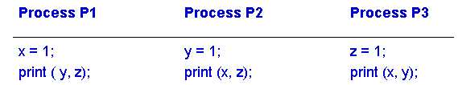

Problem 5 (10 points) Problem 10.2 in the textbook (p. 256).

Problem 6 (10 points) Problem 10.3 in the textbook (p. 256).

Problem 7 (10 points) Problem 10.4 in the textbook (p. 256).

Problem 8 (10 points) Problem 10.5 in the textbook (p. 256).

Problem 9 (10 points) Problem 10.6 in the textbook (p. 256).

