Name:

Course: CAP 4601

Semester: Summer 2013

Assignment: Assignment 2

Date: 03 JUN 2013

Complete the following written problems:

1. (10 Points) Given that a loaded coin has the following probability for coming up heads: . What is the probability that the loaded coin will come up tails? In other words, what is ?

2. (20 Points) Given loaded coin tosses are independent events and that a different loaded coin has the following probability for coming up heads twice in a row: . What is the probability that the loaded coin will come up tails twice in a row? In other words, what is ?

3. (40 Points) Given a fair coin with  and a loaded coin with , if we pick a coin at random (i.e. ) and flip it, what is the probability that it is the loaded coin given that we observe heads? In other words, what is ?

4. (40 Points) Given the following Bayes Network:

With the following probabilities:



- What is ?

- What is ?

5. (130 Points) Using the data below, construct a Naïve Bayesian Network that does **NOT** use Laplacian Smoothing to predict that an [Iris](http://en.wikipedia.org/wiki/Iris_(plant)) is an [Iris versicolor](http://en.wikipedia.org/wiki/Iris_versicolor) based on if its sepals are long or wide.

Note: [Sepals](http://en.wikipedia.org/wiki/Sepal) are the green petal-like objects surrounding a flower.

|  |  |  |
| --- | --- | --- |
| **Long Sepals** | **Wide Sepals** | **Iris versicolor** |
| false | true | false |
| false | false | false |
| false | true | false |
| false | true | false |
| false | true | false |
| false | true | false |
| false | true | false |
| false | true | false |
| false | false | false |
| false | true | false |
| true | true | true |
| true | true | true |
| true | true | true |
| true | false | true |
| true | false | true |
| true | false | true |
| true | true | true |
| false | false | true |
| true | false | true |
| false | false | true |

Do the following:

- Draw the graph of the Naïve Bayesian Network.

- Given the data above, answer the following questions:

a. What is the probability that an Iris is an Iris versicolor? In other words, what is ?

b. Given an Iris versicolor, what is the probability that its sepals are long? In other words, what is ?

c. Given an Iris versicolor, what is the probability that its sepals are wide? In other words, what is ?

d. Given an Iris versicolor, what is the probability that its sepals are both long and wide? In other words, what is ?

e. Given an Iris that is not an Iris versicolor, what is the probability that its sepals are both long and wide? In other words, what is ?

f. Given an Iris with both long and wide sepals, what is the probability that it's an Iris versicolor? In other words, what is ?

6. (60 Points) Using the data from the previous problem, construct a Naïve Bayesian Network that **DOES** use Laplacian Smoothing to predict that an Iris is an Iris versicolor based on if its sepals are long or wide.

For Laplacian Smoothing, use .

- Given the data above, answer the following questions:

a. What is the probability that an Iris is an Iris versicolor? In other words, what is ?

b. Given an Iris versicolor, what is the probability that its sepals are long? In other words, what is ?

c. Given an Iris versicolor, what is the probability that its sepals are wide? In other words, what is ?

d. Given an Iris versicolor, what is the probability that its sepals are both long and wide? In other words, what is ?

e. Given an Iris that is not an Iris versicolor, what is the probability that its sepals are both long and wide? In other words, what is ?

f. Given an Iris with both long and wide sepals, what is the probability that it's an Iris versicolor? In other words, what is ?

Complete the following programming problem on linprog4.cs.fsu.edu:

Download the ZIP file containing the directory structure and files for this programming problem: [assignment_02.zip](http://www.cs.fsu.edu/~cop4601p/assignment/02/assignment_02.zip)

1. (100 Points) Use the method of gradient descent to find the minimum of a function.

Given the function: 

With the following plots:

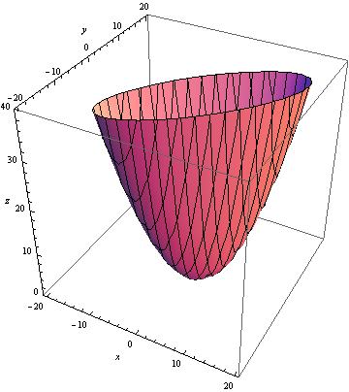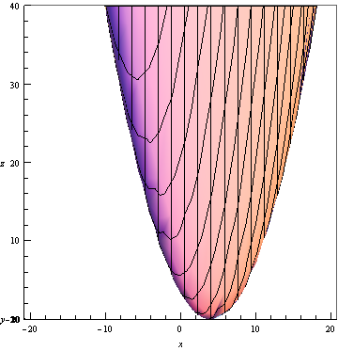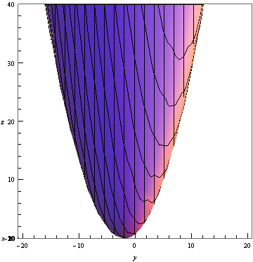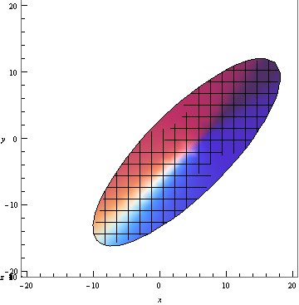

Use the method of [gradient descent](http://en.wikipedia.org/wiki/Gradient_descent) to find the  value that produces the minimum  when we start [gradient descent](http://en.wikipedia.org/wiki/Gradient_descent) from  and use the learning rate .

The [gradient descent](http://en.wikipedia.org/wiki/Gradient_descent) update formula is: ; therefore, it is  for this problem.

Stop the [gradient descent](http://en.wikipedia.org/wiki/Gradient_descent) when either:

- The difference in consecutive  values is less than . In other words, when .

- The number of full [gradient descent](http://en.wikipedia.org/wiki/Gradient_descent) iterations exceeds 1024. In other words, don't do more than 1024 updates of gradient descent.

Use the following files:

- [print.hpp](http://www.cs.fsu.edu/~cop4601p/assignment/02/gradient_descent/print.hpp): The file containing operator << to print arrays and std::vector.

- [main.cpp](http://www.cs.fsu.edu/~cop4601p/assignment/02/gradient_descent/main.cpp): The file for editing.

- [makefile](http://www.cs.fsu.edu/~cop4601p/assignment/02/gradient_descent/makefile): The makefile for linprog4.cs.fsu.edu.

Do not make changes to the makefile. Only make changes to main.cpp.

Use std::cout to output information exactly in the following format:

1: ( 0, 0 )

2: ( 0.622222, -0.577778 )

3: ( 1.12395, -1.03605 )

.

.

.

Note: The ellipses above should not be included in your output. The ellipses represent the rest of your properly formatted output for this [gradient descent](http://en.wikipedia.org/wiki/Gradient_descent) problem.

After completing Assignment 02, create an assignment_02_*lastname*.pdf file for your written assignment and an assignment_02_*lastname*.zip file for your programming assignment (where *lastname* is your last name). Ensure that your assignment_02_*lastname*.zip retains the directory structure of the original zip file. In other words, ensure your zip file has the following directory structure:

* /
  + gradient_descent/
    - print.hpp
    - main.cpp
    - makefile

Upload both your assignment_02_*lastname*.pdf file for your written assignment and your assignment_02_*lastname*.zip file for your programming assignment to the Assignment 02 location on the [BlackBoard](https://campus.fsu.edu) site: <https://campus.fsu.edu>.