CNT5505 Homework No. 5
(Given November 6, due November 13)

(Note: you can either do this as an individual homework or form a group of 2 to do this homework.)

- Consider the network of Fig. 5-12(a). Diustance vector routing is used and the following vectors have just come in to router C: from B: (5, 0, 8, 12, 6, 2); from D: (16,12, 6, 0, 9, 10); and from E : (7, 6, 3, 9, 0 4). the cost of the links from C to B, D, and E are 6, 8, 5, respectively. What is C's new routing table? Give both the outgoing line to use and the cost.

- Given the following network, list the content of all link state packets that node a will receive and show how every iteration of the Dijkstra algorithm for computing the shortest paths from node a.

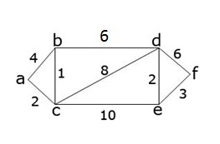

3. A Network on the Internet has a subnet mask of 255.255.240.0. What is the maximum number of hosts it can handle?

4. A large number of consecutive IP addresses are available starting at 198.16.0.0. Suppose that four organization request 4000, 4000, 2000, and 8000 addresses, respectively, and in that order. For each of these, give the first IP address assigned the last IP address assigned, and the mask in w.x.y.z/s notation.

5. Describe a way to reassemble IP fragments at the destination.

