The Electronic Stamp
Mail Server and Client
Project
Part 4: Software Design Specifications

by


SDS version 4
November 23, 2003
This Software Design Specification was prepared and provided as a deliverable for Florida State University, Software Engineering Class, CEN 5035, for Fall Term 2003. This document is based in part on the IEEE Standard 1016-1998, IEEE Recommended Practice for Software Design Descriptions.

_________________________
Gabrielle Reed,
Project Manager

_________________________
E Shen,
Repository Expert

_________________________
Stanislav Ustymenko,
Project Leader

_________________________
Yunwei Wang,
Technical Leader

Change History

Revision | Date | Author | Section/Pages  Affected | Remarks
Draft 1 | Oct 20, 2003 | R. G. Reed  E Shen  Stanislav Ustymenko  Yunwei Wang | All Initial | Framework for Design Document
Draft 2 | November 3, 2003 | R. G. Reed  E Shen  Stanislav Ustymenko  Yunwei Wang | Inserting each section as assigned | Assemblage
Version 3 | November 11, 2003 | R. G. Reed | All sections | Edit
Version 4 | November 23, 2003 | R. G. Reed | Features details and Interface images | Final edit

Table of Contents
Change History 3
Table of Contents 4
Preface 7
Table of Tables 8
Table of Figures 9
1. Introduction 10
1.1. Purpose 10
1.2. Scope 10
1.3. Definitions and Acronyms 11
2. References 12
3. Decomposition Description 13
3.1 Feature 1: EStamp Configuration Interface 13
3.1.1. Use Case Configuration Description 15
3.1.2. Configuration Data Flow Diagram 16
3.1.3. Configuration Process Flows 18
3.1.3. Configuration Process Flows 18
3.1.4. Process Analysis of the Purchasing of an eStamp aspect of Configuration 20
3.1.5. Configuration Modules Analysis 21
3.1.6. Comprehensive Set of Class Diagram 21
3.2. Feature 2: Compose and Send 24
3.2.1. Data Analysis 24
3.2.2. Process Analysis 27
3.2.3. Class Design 28
3.3. Feature 3: Receive and Sort 29
3.3.1. Collaboration 29
3.3.2. Use of Built in Filter Rules in MailPuccino 30
3.3.3.Data Analysis 31
3.3.4. 32
Process Analysis 32
3.4. Feature 4: Mail Manipulation 33
3.5. Feature 5: EStamp Vendor 34
Specification 34
3.5.1. Use case Description 34
3.5.2. Data Flow Description 35
3.5.3. Process Analyses 36
3.5.4. Module Design 38
3.5.5. Prototype Design for Delivery of an eStamp 38
3.6. Feature 6. eStamp Management 38
3.7. Feature 7: eStamp Interface 39
4. Dependency Description 40
4.1. Intermodule Dependencies 40
4.2 Interprocess Dependencies 40
4.3 Data Dependencies 40
5. Interface Description 41
5.1 Receiving Feature - Rule Filter GUI Interface 41
5.2 Compose and Send Email GUI Interface 44
5.3 eStampBook GUI Interface 47
6. Detailed Design 54
Appendix A: EStamp Package Class Source Listing and Documentation 55
Appendix B EStamp 56
estamp Class Estamp 56
Field Detail 56
FROM_NAME 56
FROM_EMAIL 56
TO_NAME 56
TO_EMAIL 56
NAME 56
ISSUE_DATE 57
EXPIRE_DATE 57
ACTIVE 57
REUSABLE 57
VENDOR_ID 57
PUBLIC_KEY 57
PRIVATE_KEY 57
FIELDS 57
m_fields 57
Constructor Detail 57
Estamp 57
Estamp 58
Estamp 58
encryptEstamp 58
equals 58
get 58
getFields 58
init 59
isValid 59
set 59
setFields 59
Appendix C: EStamp Vendor 60
Prototype Client Side Vendor Service code 60
Class Description 61
EstampVendor Class eStampVendor 61
registerAccount 61
login 61
getStamp 61
EstampVendor Class RSA 62
Encrypt 62
Decrypt 62
EstampVendor Class AccountManager 62
Validate 62
registerAccount 62
getAccount 62
Appendix D: eStamp Manager 63
estamp Class EstampManager 63
m_estamps 63
m_publicKey 63
m_privateKey 63
m_vendorIDs 63
EstampManager 63
addEstamp 64
addEstamp 64
clear 64
getEstamps 64
getHostEmail 64
getHostName 64
getKeys 65
getSelectedEstamp 65
getVendorID 65
getVendorIDs 65
loadEstamp 65
remove 65
removeExpriredEstamps 66
saveEstamps 66
setEstamp 66
size 66
testing 66

Preface

This document is prepared as part of the requirements for a Software Engineering class. The information contained within is based on preliminary information provided in the textbooks, the Software Engineering Class and websites. We would like to thank the PALS Learning Systems Institute at the College of Education for the use of equipment and software provided under National Science Foundation Grant # IIS-0218692.

Table of Tables

Table 1: Design Features and Reference Documents for Requirements 10
Table 2: Features Accessible to User through the Configuration Interface 14
Table 3: Configuration of eStamped processes not implemented in MailPuccino 20
Table 4: Design Classes for Implementing Sending Functions 24
Table 5: Design Classes for Implementing Receiving Functions 29
Table 6: Email Filter Rules and Actions to Implement eStamp Functionality 30
Table 7: Design Classes for Implementation of Mail Manipulating Function 33
Table 8: Vendor Requirements 34
Table 9: Receiving Processes of eStamped Message not implemented in MailPuccino 37
Table 10: eStamp Management Requirements 38
Table 11: eStamp Interfaces 39

Table of Figures
Figure 1: Data Flow Diagram for Logging an eStamp for future use 16
Figure 2: Data Flow Diagram to invoke or revoke an eStamp 17
Figure 3: Sequence diagram for purchase of eStamp 18
Figure 4: Sequence Diagrams to display and select eStamp from eStampBook 19
Figure 5: Sequence Diagram of changing the state of the eStamp 20
Figure 6: Filtering and eStamping Modules 21
Figure 7: EStamp Class Diagram with related Mail Puccino classes 23
Figure 8: Data Flow diagram for the Compose Email Feature 26
Figure 9: Sequence Diagram of the Compose and Send Feature of the eStamp Mail Client 27
Figure 10: Data Flow Diagram for the Receiving Feature 31
Figure 11: Sequence Diagram of the Receiving Feature 32
Figure 12: Vendor's Involvement in eStamp Process 36
Figure 13: Process Analysis of Purchasing an eStamp 37
Figure 14: StampVendor's Class Diagram 38
Figure 15: Setting up the eStamp configuration using filter configuration 41
Figure 16: Configuration Filters Panel for eStamp use 42
Figure 17: Selection of Action to Log Estamp if Reusable Ruleset is selected. 43
Figure 18: Selections under Log eStamp Action 43
Figure 19: Selection of the New Message option when you click the write mail icon on the opening panel. 44
Figure 20: Opening of the Compose email panel, and selection of the eStamp panel. 45
Figure 21: Configure eStamp panel pops up when the “New eStamp” button is clicked. Matching eStamps from the eStamp Log appear in the List of available eStamps, with the default dates. 45
Figure 22: Select Option to save new eStamp for future reuse. 46
Figure 23: Client selects the appropriate eStamp to be used for the email. 46
Figure 24: Clicking on the eStamp Book Icon on the first panel. 47
Figure 25: The eStampBook panel opens and displays eStamps in the list. 48
Figure 26: By Selecting an eStamp in the list, the panel displays the details of that eStamp. 49
Figure 27: Active and Reusable State values of the eStamp can be changed. 50
Figure 28: eStamp Vendors can be added or deleted from the Vendor List. 51
Figure 29: After clicking the Add button, enter the new vendor information. 52
Figure 30: Selects Vendor list to see available vendors. 53

1. Introduction

1.1. Purpose

This document outlines the Software Design Specifications as part of the design plan and specifications for adding the eStamp functionality to an existing email client, MailPuccino.
This document expands the functionality described by the features in the Software Requirements Specifications (SRS) v3.0. Each feature discussed will describe the existing functionality of MailPuccino, and describe the additional classes, attributes and methods to be implemented.

1.2. Scope

This document takes the features as outlined in the SRS and expands each of the features to include the design issues of user interface, data flow, process analysis and then module design. The features are described by the Use Case names given in the descriptions and diagrams in the SRS. Specific requirements have the form of R# where R indicates it is a requirement. In the design process, additional requirements were added as needed for the implementation, based on the internal requirements. These are given numbers preceded by an S to specify a system requirement.
The features included in this report are listed in Table 1.

Table 1: Design Features and Reference Documents for Requirements
Feature Number | Use Case Name | Reference
1. | Configuration | SRS Appendix A
2. | Send | SRS Appendix B
3. | Receive | SRS Appendix C
4. | Mail Manipulation | SRS Appendix D
5. | Vendor | SRS Appendix E
6. | eStamp Management | This Document
7. | eStamp Interface | This Document

Because this project incorporates existing code, the design document with take a Feature based approach to the design document instead of a typical Object Oriented Design. The discussion on each Feature will incorporate aspects of the Object Oriented Design(OOD) and addresses the structure, function, the interfaces, the application data, and a detailed design description ( methods) in the following way: The structure is discussed and described in the Entity Relationship Diagrams(ERD) for the main Use-Cases in the Software Requirement Specifications(SRS). The interfaces are illustrated in the dataflow and the sequence diagrams. The Graphical User Interfaces are discussed and illustrated with mock ups of the panels to be implemented. The application data is addressed in the discussion of the dataflow diagrams. Analysis is performed using a modified CRC card called an Analysis Table, to assign responsibilities to classes. This also determines the methods and the data needed as arguments to the method and the desired return data. The detailed design description is discussed and illustrated by the class diagrams, which illustrate the relationships between classes, and outlines the members and methods necessary to implement the features.

1.3. Definitions and Acronyms

SRS is the Software Requirements Specifications Report located at the SEGY website at http//:www.cs.fsu.edu/~baker/sweng/

OOD is Object Oriented design

ERD is the Entity Relationship diagram

DFD is the data flow diagram

2. References

IEEE Recommended Practice for Software Design Descriptions, IEEE Std 1016-1998 (Revision of IEEE Std 1016-1987) Available at http://web.nps.navy.mil/~nschneid/is3020/PDF/1016-1998.pdf

Roger Pressman, Software Engineering, 5th Edition, Chapter 21: Object Oriented Analysis and Chapter 22: The Object-Oriented Design Process © 2001.

Eu Tak, Kong, MailPuccino (email Client), available at http://www.kingkongs.org/mailpuccino/

Strickland, Sarah, Sample for Software Engineering Design Document

3. Decomposition Description

This section of this report decomposes each use-case feature into its data flow processes by examining its data flow diagram and its process flow through the use of sequence diagrams. These assist us in determining the preliminary members and methods of the modules that need to be implemented, or the modifications to existing modules to implement the feature. This document uses the names of the use cases in the Software Requirement Specification document as the names of the features. This section includes the description of the intended design to meet the requirements. When appropriate, the use cases will be expanded to include system requirements. This section also incorporates a number of revised sequence diagrams, updated from the initial prototype and analysis.

The Features discussed in this document are:

EStamp Configuration Interface

3.1 Feature 1: EStamp Configuration Interface

The design of the eStamp Configuration Interface will be implemented as described by the diagrams, as outlined in this section. These incorporate the specifications that are outlined in SRS Appendix A.
The following Table 2 summarizes the requirements specifications functionality not already included in MailPuccino. These requirements will be satisfied by the addition of attributes and methods to the classes responsible for the functionality.

SRS Appendix A contains the requirements specifications for this feature.
Table 2: Features Accessible to User through the Configuration Interface
Ref # | Requirement Description | MailPuccino Functionality | Class Responsible for Additional Feature/Functionality
Use case SRS | Set up routine purchase to buy stamps from a vendor |  | eStampConfigur
Use case SRS | Setup routine to Authenticate stamps |  | eStampConfigur
R1.5 | User may log an e-stamp for further use |  | eStampManager and eStamp, using a filter Action, display with eStampBookFrame
R1.6 | User may invoke / revoke an e-stamp for / from further use. |  | Member of eStamp Class

3.1.1. Use Case Configuration Description

Primary Actor:
Email Client User

State Holders:
Mail Sender: wants to set up a routine to buy stamps
Mail Receiver: wants to set up a routine to authenticate stamps
Mailer Vendor: want to set up a routine to sell stamps

Pre-conditions:
The email user is identified by the email client
Email client is connected with the email server.

Post-conditions:
The authenticating and buying stamps settings are saved.

Mail Flow 1:
1. Sender authenticated on mail client
2. Click on the configuration button for buying a stamp
3. Specify how many stamps to buy
4. Choose ways of payment
5. Save the setting for later use

Extension 1:
1-5a: use saved settings; it should be the default. Email client will pop up a window to ask user.

Mail Flow 2:
1. Receiver authenticated on mail client
2. Click on the configuration button for authenticated email
3. Specify the way the stamp is to be authenticated
4. Save settings

Extension 2:
1-4a: use saved settings; it should pop up a window to ask the user to use default configuration settings or a new configuration.

3.1.2. Configuration Data Flow Diagram

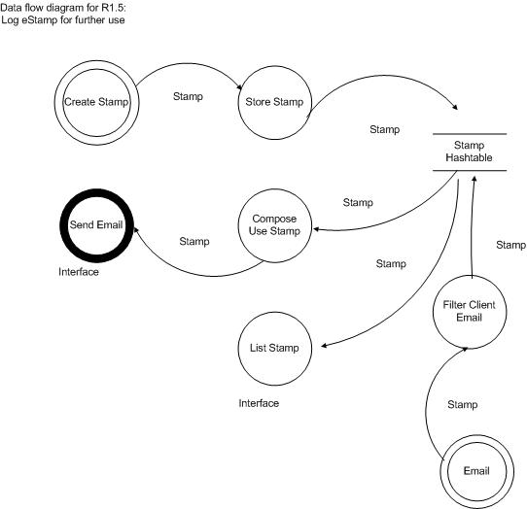
Figure 1: Data Flow Diagram for Logging an eStamp for future use

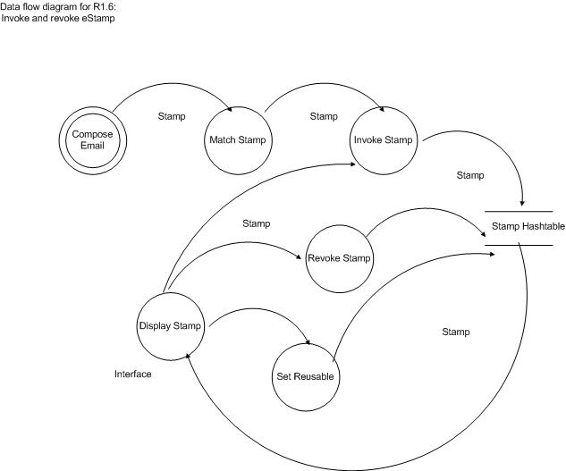
Figure 2: Data Flow Diagram to invoke or revoke an eStamp

3.1.3. Configuration Process Flows

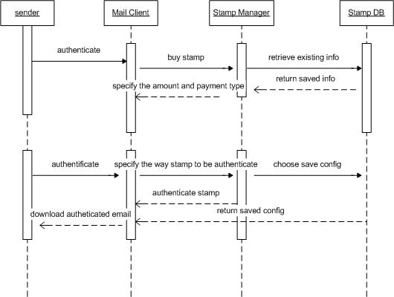
Figure 3: Sequence diagram for purchase of eStamp

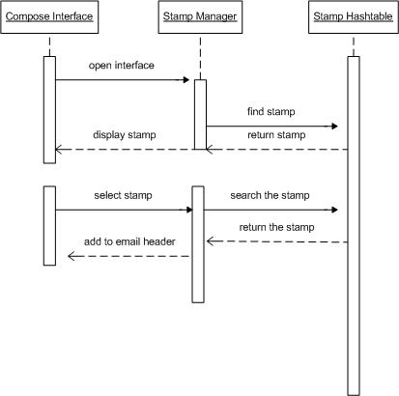
Figure 4: Sequence Diagrams to display and select eStamp from eStampBook

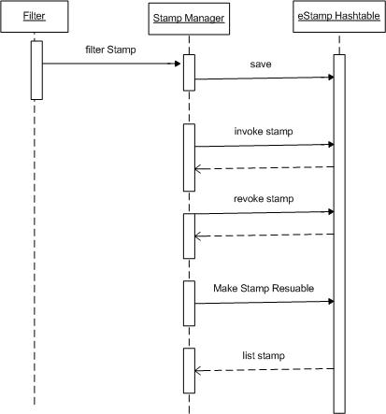
Figure 5: Sequence Diagram of changing the state of the eStamp

3.1.4. Process Analysis of the Purchasing of an eStamp aspect of Configuration

The following analysis table lists the processes not already in MailPuccino, that were illustrated in the above Sequence and Data Flow diagrams. The responsibilities require the creation of:
- An eStamp that contains information sufficient for determining its reusability, its ability to be revoked and invoked.
- An eStampBook that is the format for listing saved eStamps and their user controlled attributes.
- An eStamp manager that contains and retrieves and displays eStamps.

Table 3: Configuration of eStamped processes not implemented in MailPuccino
Method | Data Input | Data Output | Responsible Class
Invoke eStamp | eStampManager | eStampHashTable | eStampBook
Revoke eStamp | eStampManager | eStampHashTable | eStampBook
List eStamp attributes | eStamp | eStampBookFrame | eStampManager
Authenticate | UserInfo | Interface | authenticate
Make eStamp reusable | eStamp | eStamp | eStampFilter
Buy eStamp | User | True/False | eStampManager

3.1.5. Configuration Modules Analysis

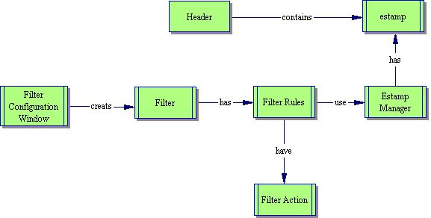
Figure 6: Filtering and eStamping Modules

3.1.6. Comprehensive Set of Class Diagram

The class diagram illustrated in Figure 7 is a comprehensive set of the classes used in the design. The class details are included in the Java Documentation included on the SEGY website and incorporated in the Appendices.. This class diagram includes the Mail Puccino classes along with the new classes of EStamp, EstampManager, EStamp BookFrame, EstampChoicePanel and EstampConfigurePanel, Filter actions of AutoReply, LogEstampAction, and VendorFrame.

The EStamp contains the methods and members for storage of the attributes of the estamp such as the sender and recipient addresses, the valid ates, the reusability and the invoked or revoked status of a estamp.

The EstampManager maintains the list of EStamps and displays and interfaces with the classes using the EStamp

The EStampBookFrame is the GUI interface for the display and use of EStamps.

The EstampChoicePanel is a subpanel of the EStampBookFrame, that allows for the selection of the eStamp.

EstampConfigurePanel is the GUI interface for the setup of the EStamp content.

Filter actions of AutoReply is a special action used in the Filter Rules set that will allow for the sending of a email when a stamp is not available.

LogEstampAction is a special action used in the Filter Rules set that will allow for the recording of the EStamp that is purchased and received as set up in the Configuration panel.

The VendorFrame is used to search for allowable vendors and to add or edit existing vendors.
Java Documentation of the Skeleton Classes are included in the appendices

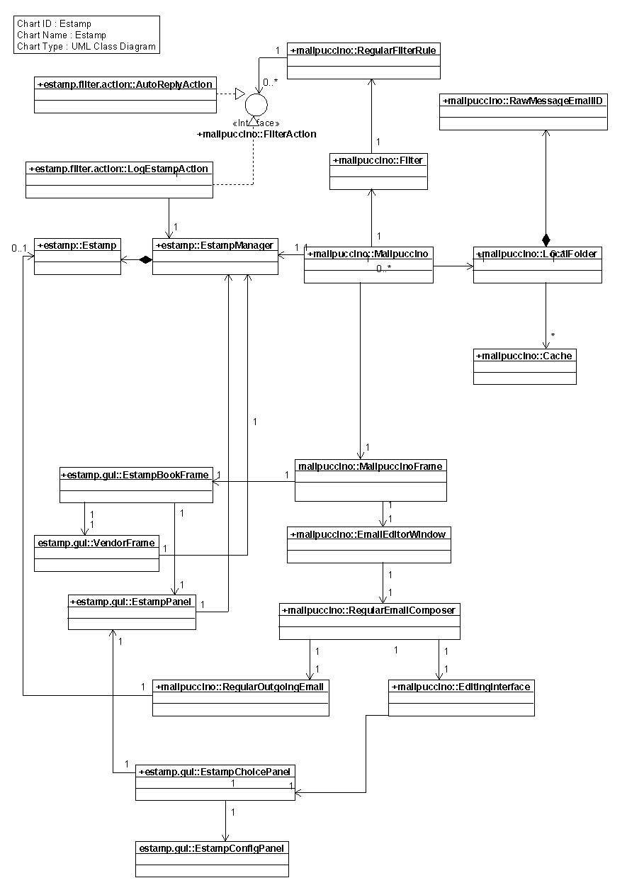
Figure 7: EStamp Class Diagram with related Mail Puccino classes

3.2. Feature 2: Compose and Send

The design of the eMail Manipulation function of Send will be implemented using the diagrams as outlined in this section. These follow the specifications that are outlined in SRS Appendix B. The following table summarizes the requirements specifications functionality not already included in MailPuccino. These requirements will be satisfied by adding functionality to the classes responsible for the functionality.

Table 4: Design Classes for Implementing Sending Functions
Ref # | Requirement Description | MailPuccino Functionality | Class/Method Responsible for Additional Feature/Functionality
R2.1.1 | User may use the existing e-stamp in an email header when it is a reply to the email. |  | eStamp.reusable
R2.1.2 | User may select an existing e-stamp from logged e-stamps. |  | eStampManager
R2.3 | Email client shall attach e-stamp to the header of email. |  | regularEmailComposer
R2.4 | User shall send email to the email server by clicking one button in email client. | present
R2.5 | User shall log the e-stamp for return use by clicking one checkbox in email client. |  | eStampChoicePanel, eStamp

3.2.1.

Data Analysis

The eStamp.reusable attribute must be true in order to be able to select the eStamp for reuse.
eStampManager displays and stores the eStamps for reuse.

regularEmailComposer is used to edit the email message and write the estamp to the header.

eStampChoicePanel, User can select a box on the choice panel and it will change the eStamp attribute reusable to true.

The eStamp member reusable needs to be able to be changed by other classes through a public method to the member.

The following dataflow diagram illustrates the type of data that is exchanged and the methods that need to be represented in the Feature Send.

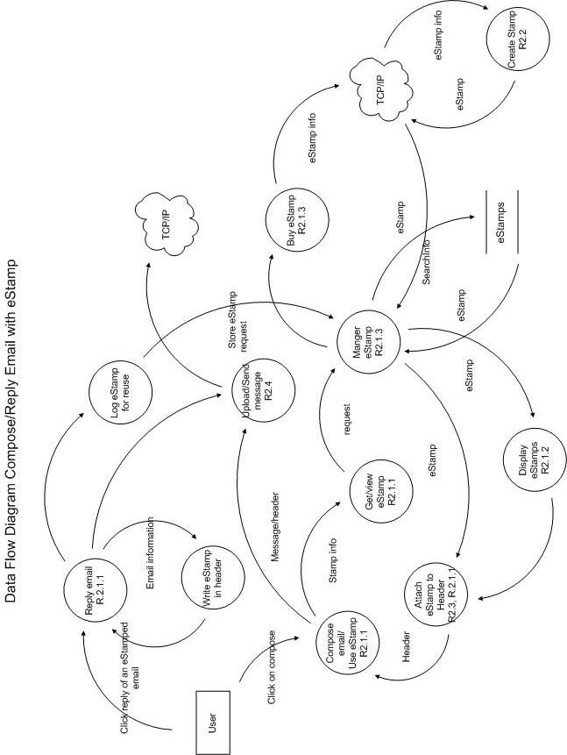

Figure 8: Data Flow diagram for the Compose Email Feature

3.2.2. Process Analysis
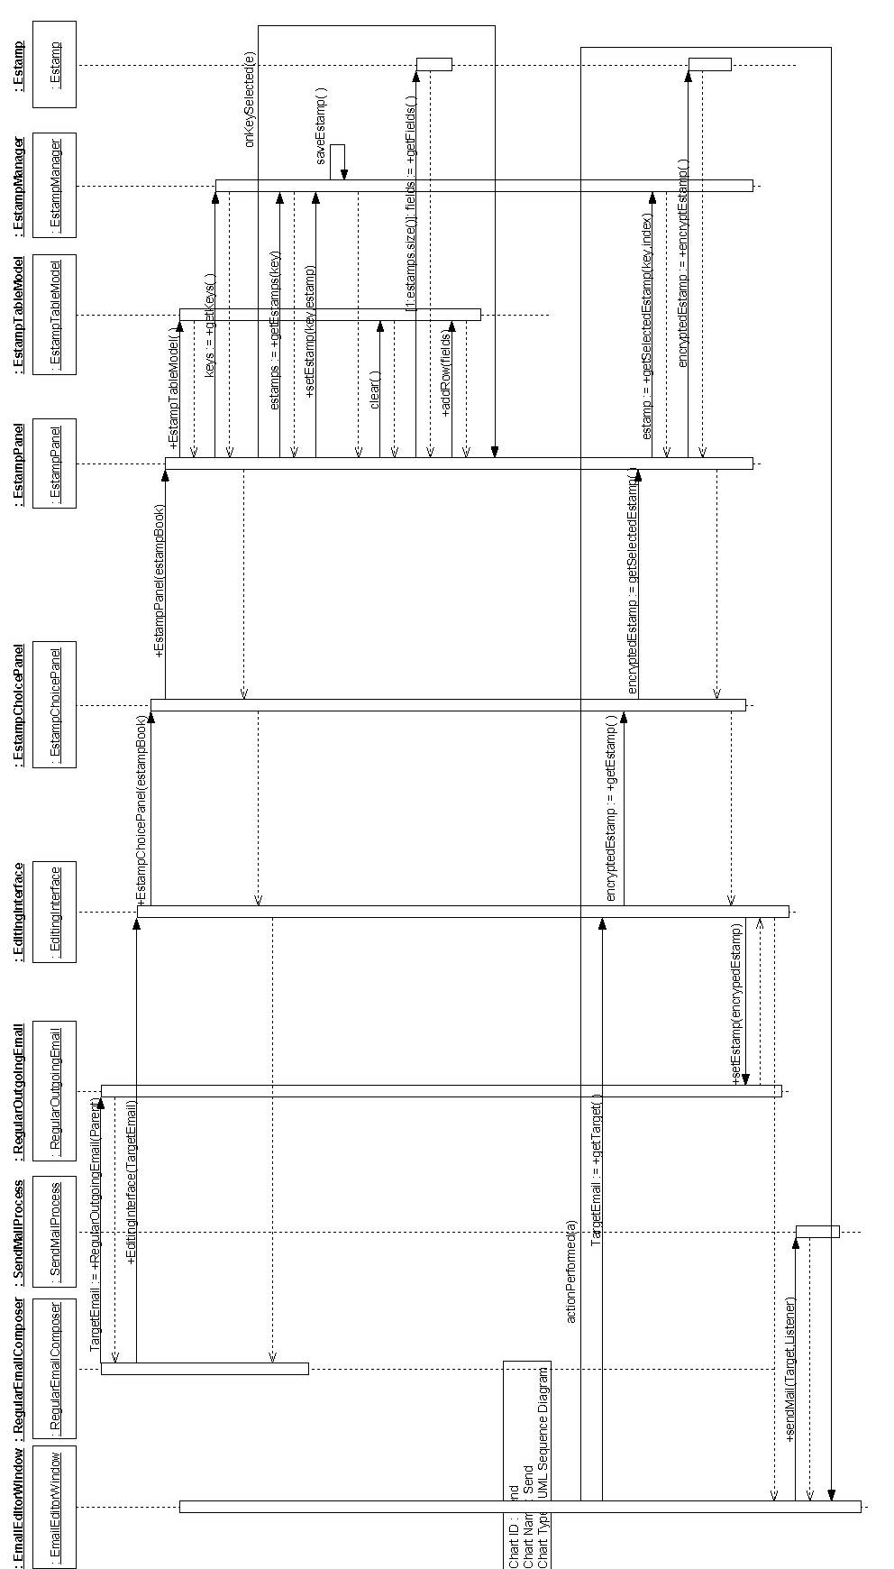
Figure 9: Sequence Diagram of the Compose and Send Feature of the eStamp Mail Client

3.2.3. Class Design

eStamp.reusable is an attribute that needs to be included in the eStamp class. This is incorporated into an estamp sent to another and signals to the recipient that the stamp will be recognized by the sender for any return mail.

The eStampManager returns and displays the estamps associated with any to addressee.

The regularEmailComposer is a Mail Pucinno Class that is used to add a EStamp Tab

The eStampChoicePanel is the GUI interface that allows the selection of one of the eStamps for use.

eStamp

3.3. Feature 3: Receive and Sort

The design of the Receive and Sort Feature will be implemented using the diagrams as outlined in this section. These follow the specifications that are outlined in SRS Appendix C.
The following table summarizes the requirements specifications functionality not already included in MailPuccino. These requirements will be satisfied by the addition of attributes and methods to the classes responsible for the functionality.

3.3.1. Collaboration

Table 5: Design Classes for Implementing Receiving Functions
Ref # | Requirement Description | MailPuccino Functionality | Class Responsible for Additional Feature/Functionality
R3.1 | User shall begin receiving emails from email server by clicking one button in email client or when the email client is launched. | Automatic Retrieval
R3.2 | Email client shall extract e-stamp from the header of email before putting the email into folders. | By use of filter rules | Filter rule and eStampManager.getEStamp()
R3.2a | User shall read a received Regular email message in email client. | present | Filtered to specified LocalFolder
R3.2b | User shall read a received eStamp email message in email client. | Built in filter configuration | eStamp Manager using filterAction storing to specified LocalFolder
R3.3 | Email client shall check the validity of e-stamp |  | eStamp.isValid()
R3.4 | Email client shall separate emails with valid e-stamp from those without e-stamp or without valid e-stamp and put into different folders. | Built-in filter actions | Filter rule includes eStamp.isValid() and location folders for Valid, Invalid or Missing eStamps
R3.5 | Email client may generate auto-reply message for emails without e-stamp or without valid e-stamp. |  | Filter action created to generate auto-reply message for Invalid or Missing eStamps

3.3.2. Use of Built in Filter Rules in MailPuccino

MailPuccino already contains options to configure email filter rules. It will execute the action portion of the rule format when the condition that is set up in the rule returns a True state. Class members and class methods may be used as conditions for these rules. This flexibility allows us to check for the validity of a stamp with the execution of public methods of an eStamp class.
Table 6 contains examples of the filter rules to be implemented in the existing email client.

Table 6: Email Filter Rules and Actions to Implement eStamp Functionality
Rule Number | Condition | Methods to be Implemented | Action
1. | Email without eStamp in header OR Invalid eStamp | getHeader(),  eStamp.isValid() | Move to specified LocalFolder such as Trash, autoReply()
2. | Valid eStamp and reusable | getHeader(),  eStamp.isValid(),  eStamp.getReusable() | Move to specified LocalFolder such as Inbox, saveEStamp()
3. | Valid eStamp and not reusable | getHeader(),  eStamp.isValid(),  eStamp.getReusable() | Move to specified local folder such as Inbox

3.3.3.Data Analysis

By looking at the data flow we can understand what attributes are needed in each of the entities. It also clarifies what processes are needed. These processes will be incorporated as methods in existing Classes. The data structures are assigned to classes as members. . The diagram may also indicate the need of a new class

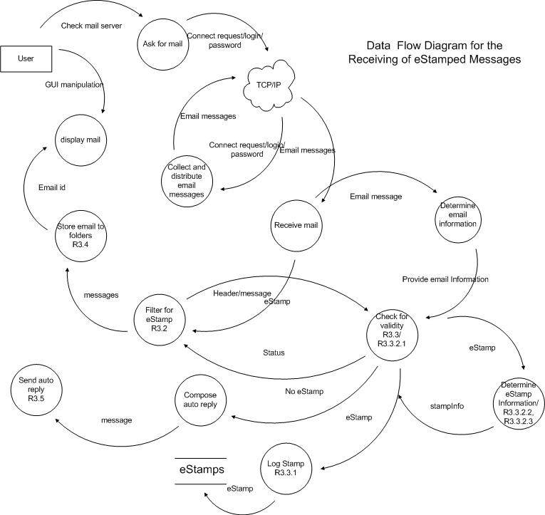
Figure 10: Data Flow Diagram for the Receiving Feature

3.3.4.

Process Analysis

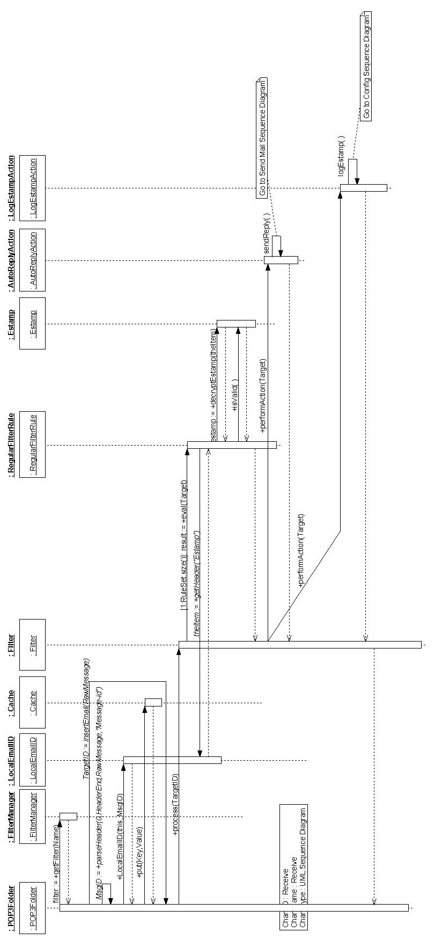
Figure 11: Sequence Diagram of the Receiving Feature

3.4. Feature 4: Mail Manipulation
The design of the Mail Manipulation will be implemented using the diagrams as outlined in this section. These follow the specifications that are outlined in SRS Appendix D. The following table summarizes the requirements specifications functionality not already included in MailPuccino. These requirements will be satisfied by the addition of functionality to the classes responsible for that functionality.

Table 7: Design Classes for Implementation of Mail Manipulating Function
Ref # | Requirement Description | MailPuccino Functionality | Class Responsible for Additional Feature/Functionality
R1.1 | User shall compose a new email message in email client. | present | eStamp is provided by Vendor.purchase() if stamp is not available
R1.3 | User shall reply and/or forward an email message saved in email client. | present | Reply can reuse stamp, forward is like a new compose.
R1.4 | User shall delete an email message saved in email client. | present localFolder

3.5. Feature 5: EStamp Vendor

Specification

The design of the eStamp Vendor will be implemented using the diagrams as outlined in this section. These follow the specifications that are outlined in SRS Appendix E.
The following table summarizes the requirements specifications functionality not already included in MailPuccino. These requirements will be satisfied by the Vendor package.

Table 8: Vendor Requirements
Ref # | Requirement Description | MailPuccino Functionality | Class Responsible for Additional Feature/Functionality
R2.1.3 | Email client shall request e-stamp from e-stamp vendor if email doesn’t include an e-stamp as described in R2.1.1 and R2.1.2 |  | eStampVendor eStampVendor.getEStamp()
R2.2 | E-stamp vendor shall generate and return e-stamp to email client. |  | eStampVendor eStampVendor.createEStamp ( clientinformation)
S6 | Transaction records should be kept. |  | AccountManager, AccountDB, Transaction
S7 | eStamps are to be constructed using client-provided information and encrypted and provided to the Client for writing to Header. |  | AccountManager, Account, Stamp, RSA

The following is a description of the Encryption and Certification of an eStamp scenario:

3.5.1. Use case Description
Primary Actors:
Sender, Receiver, Vendor

Stakeholders and Interests:
Sender and Receiver of emails want to have secure stamp generation and distribution by simple protocol, with minimal overhead.
The Vendor would be responsible for the publication and maintenance of public keys, creating and encrypting eStamps and keeping logs.

Preconditions:
The Sender collected information for the eStamp creation. Sender had registered an Account in the Vendor system. Vendor’s Public Key is known to both Sender and Receiver (key distribution is outside of this case’s scope; e.g., the key may be published as a Web resource with a universally known URI, in plain text, and protected from forgery. Security is provided by an asymmetric encryption scheme like the RSA algorithm).
Post-conditions:
An encrypted eStamp is created, validated and stored by the Sender, ready for use.
Basic Flow:
.
- Sender connects to the Vendor and provides valid login and password, initiating the session.
- Vendor registers the session and responds to Sender with Session Cookie – unique text string identifying session.
- Sender requests new stamp, providing Vendor with receiver’s email address and desired valid date range.
- Vendor collects information required, creates stamp, encrypts it and returns to the Sender.
- Sender records the stamp for use.
- Sender ends session.

3.5.2. Data Flow Description
The dataflow diagram shows the data that is exchanged, recorded and used during the Purchase Stamp scenario and data manipulation flow.
Figure 12: Vendor's Involvement in eStamp Process

3.5.3. Process Analyses
The following sequence diagram shows an actual process and classes involved in creating a new stamp.

The following table lists the processes not already in MailPuccino, that was diagrammed in the above Data Flow graph. The responsibilities require the creation of an eStamp that contains information sufficient for determining its validity, in an encrypted form. The Account retains or procures the Sender information. The AccountManager provides account manipulation service. The RSA class implements encryption algorithm. The StampVendor communicates with the client. The eStamp holds the specific eStamp information.

Figure 13: Process Analysis of Purchasing an eStamp

Table 9: Receiving Processes of eStamped Message not implemented in MailPuccino
Method | Data input | Data output | Responsible Class
Login | Login, password | Session cookie | StampVendor
Purchase Stamp | Stamp info | eStamp | StampVendor
Register account | Client and payment info | True, false | AccountManager
Create stamp | Account info, stamp info | String | eStamp
Encrypt | String | String | RSA
Log transaction | Client, stamp, payment info, time, date | True/false | AccountDB
Logout | Null | Null | StampVendor

3.5.4. Module Design
The following class diagram illustrates relations of modules with the processes incorporated as methods and the data elements as attributes of appropriate classes as displayed in the above tables and diagrams.

Figure 14: StampVendor's Class Diagram

3.5.5. Prototype Design for Delivery of an eStamp
The use of an URL socket is used for the prototype as a method of generating an eStamp until the vendor software has been implemented.. This will be replaced by a module using RMI or Server sockets .

3.6. Feature 6. eStamp Management

This document contains the specifications for this feature.

Table 10: eStamp Management Requirements
S1 | eStamps are stored in an easily retrievable format. | Class eStampManager
S2 | eStamp contains information and methods as needed. | Class eStamp

3.7.

Feature 7: eStamp Interface

This document contains the specifications for this feature.

Table 11: eStamp Interfaces
R3.3.1 | Email client shall check its logged e-stamps. | eStampBookFrame.display()
S4 | The eStamps are to be easily used. | eStampChoicePanel
R3.3.2.1 | Email client shall request e-stamp vendor to authenticate the e-stamp  (this is revised to be encrypted within the email client). |  | eStamp.isValid() using Vendor.pubKey to decode the eStamp values
R3.3.2.2 | Email client shall check the recipient of the e-stamp. |  | eStamp.toEmailAddress,  eStamp.fromEmailAddress
R3.3.2.3 | Email client shall check the time frame of the e-stamp. |  | eStamp.issueDate,  eStamp.expireDate
S5 | The eStamps can be listed. | eStampPanel

4. Dependency Description

4.1. Intermodule Dependencies
The intermodule dependencies are captured in the class design included in Feature Configure.

4.2 Interprocess Dependencies
The interprocess dependencies are illustrated in the data flow diagrams of the above features. These will be reviewed and incorporated within the same package of classes.

4.3 Data Dependencies
The data dependencies are very limited in this design.

5. Interface Description

Receiving Feature - Rule Filter GUI Interface

The action of the email client on incoming email depends on the configuration of the filter rules set up. The feature configuration is initiated using the tool box, by selecting Config Filters from the dropdown menu as shown in Figure 1.

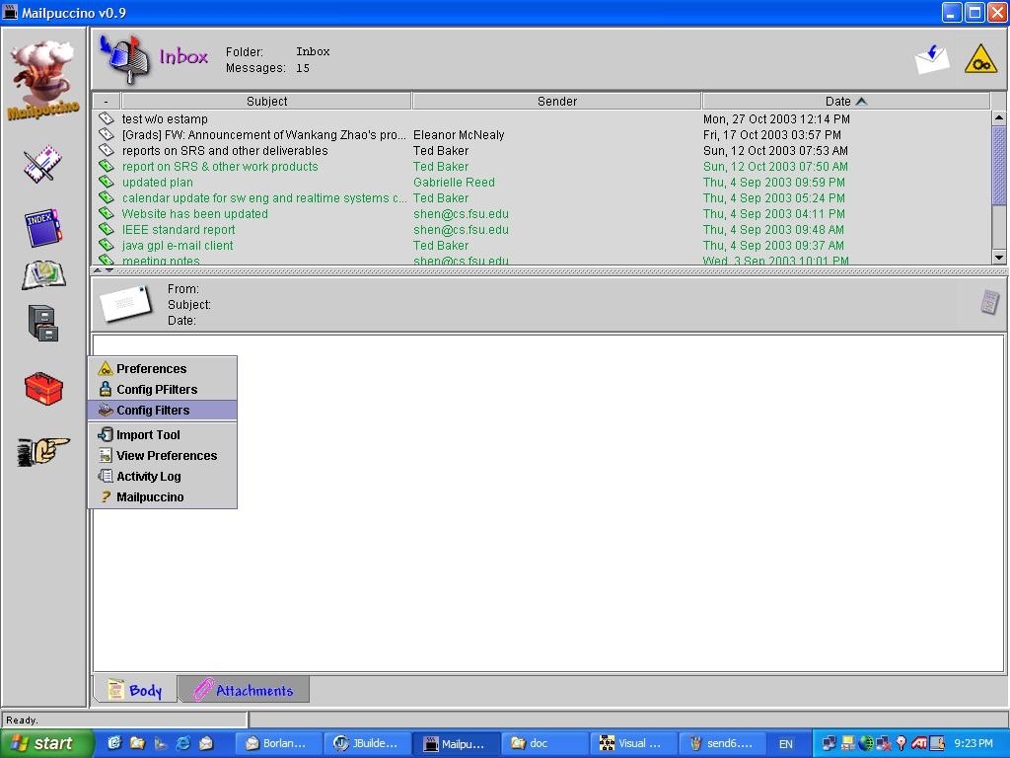
Figure 15: Setting up the eStamp configuration using filter configuration

The Configure Filters panel opens and provides options to select existing filter rules, or construct their own as in Figure 2. User selects the eStamp checker rule set for use. The desired rule set is shown in the list, where they may be selected by the user by clicking on the appropriate item. In the example in Figure 2, the first rule will check if the eStamp is valid. The second rule will check to see if the eStamp received will be reusable. These rules will be executed on each email, with or without the estamp in the header of the email.

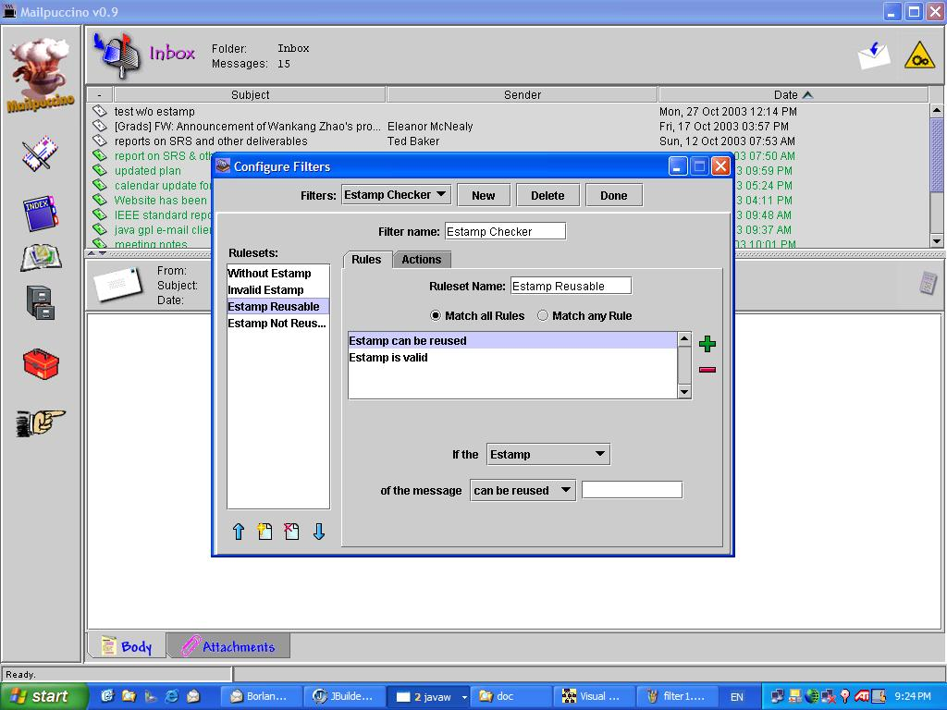
Figure 16: Configuration Filters Panel for eStamp use

Specific actions can be set in the Actions section to be performed if the rule is true.
Any of the built-in actions are permissible, such as move, copy, save message or log the eStamp, or execute an application.

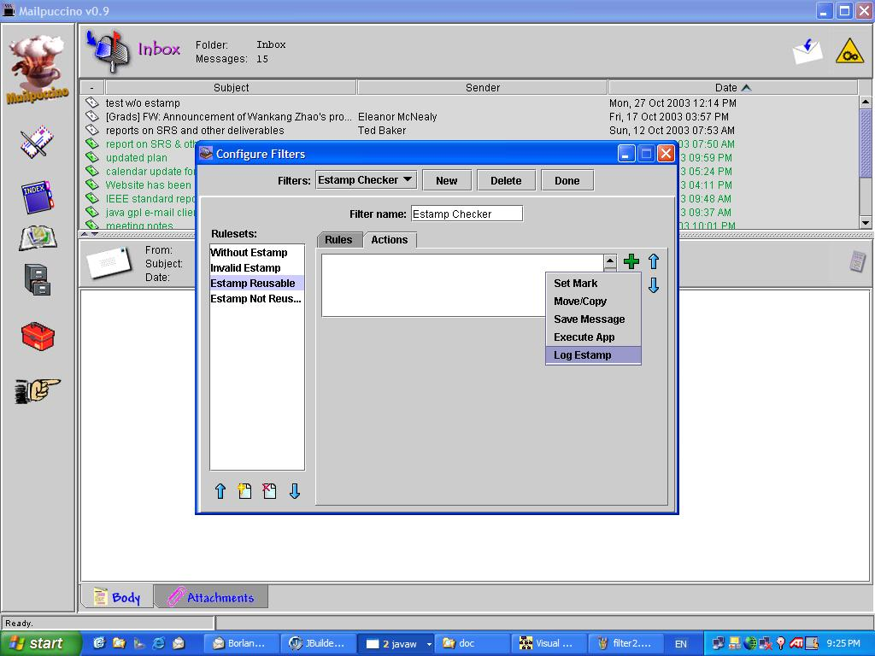
Figure 17: Selection of Action to Log Estamp if Reusable Ruleset is selected.

Filter has option to log the eStamp or not as choices under log Action (to save it or not).
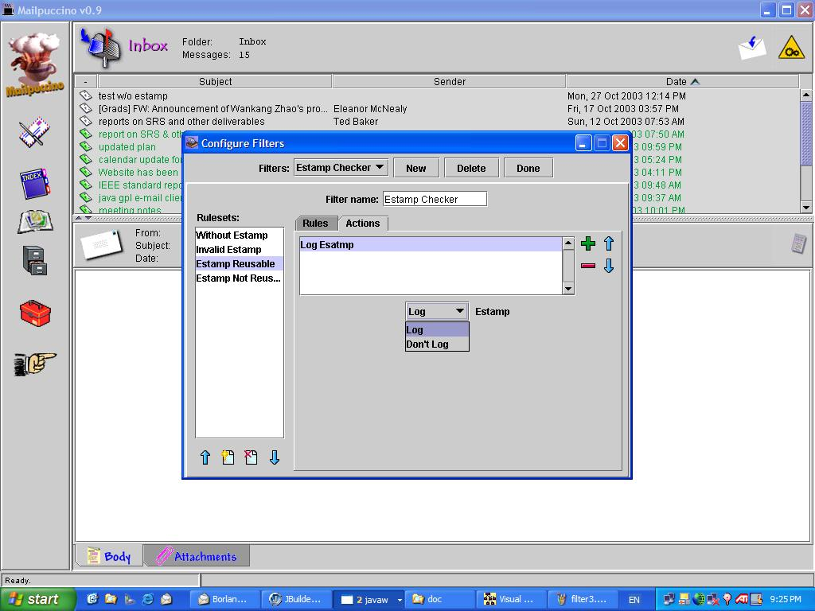
Figure 18: Selections under Log eStamp Action

Compose and Send Email GUI Interface

This next section describes the GUI interface that will be used to implement the Sending feature of the email client:

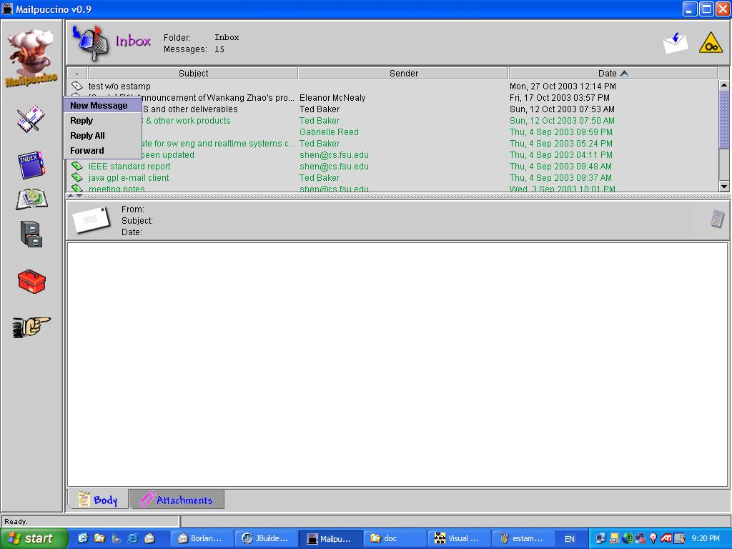
Figure 19: Selection of the New Message option when you click the write mail icon on the opening panel.

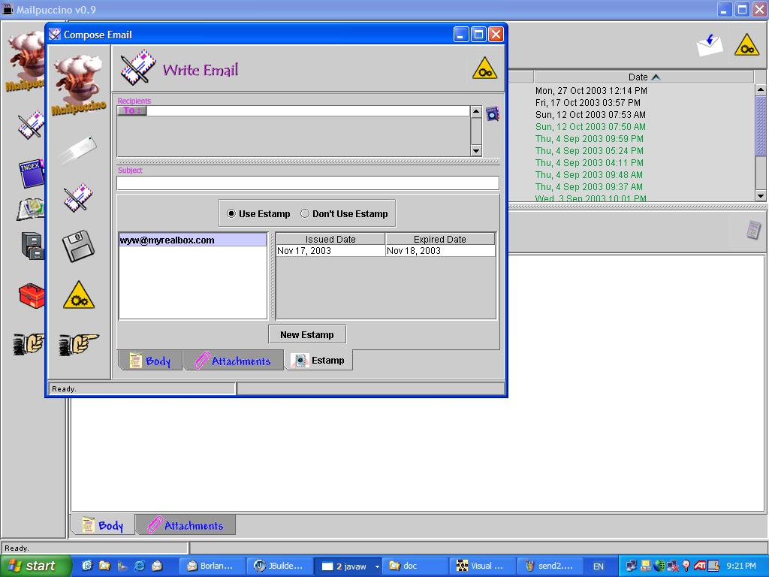
Figure 20: Opening of the Compose email panel, and selection of the eStamp panel.

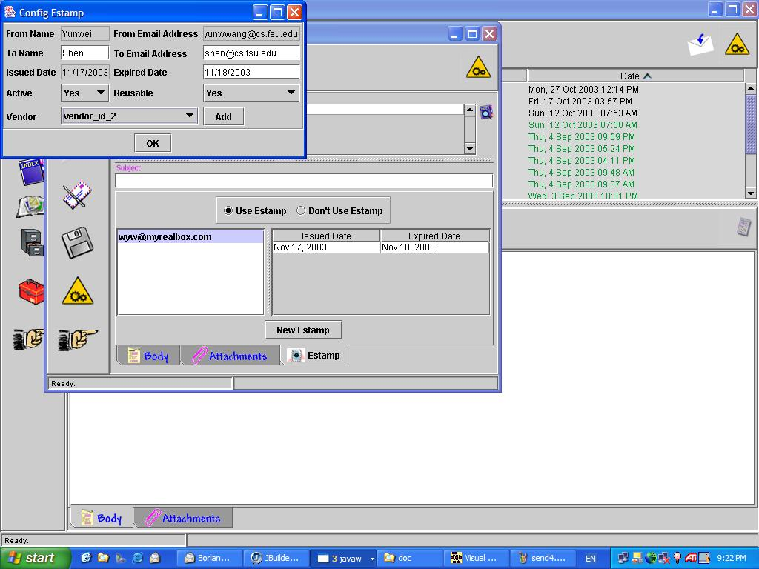
Figure 21: Configure eStamp panel pops up when the “New eStamp” button is clicked. Matching eStamps from the eStamp Log appear in the List of available eStamps, with the default dates.

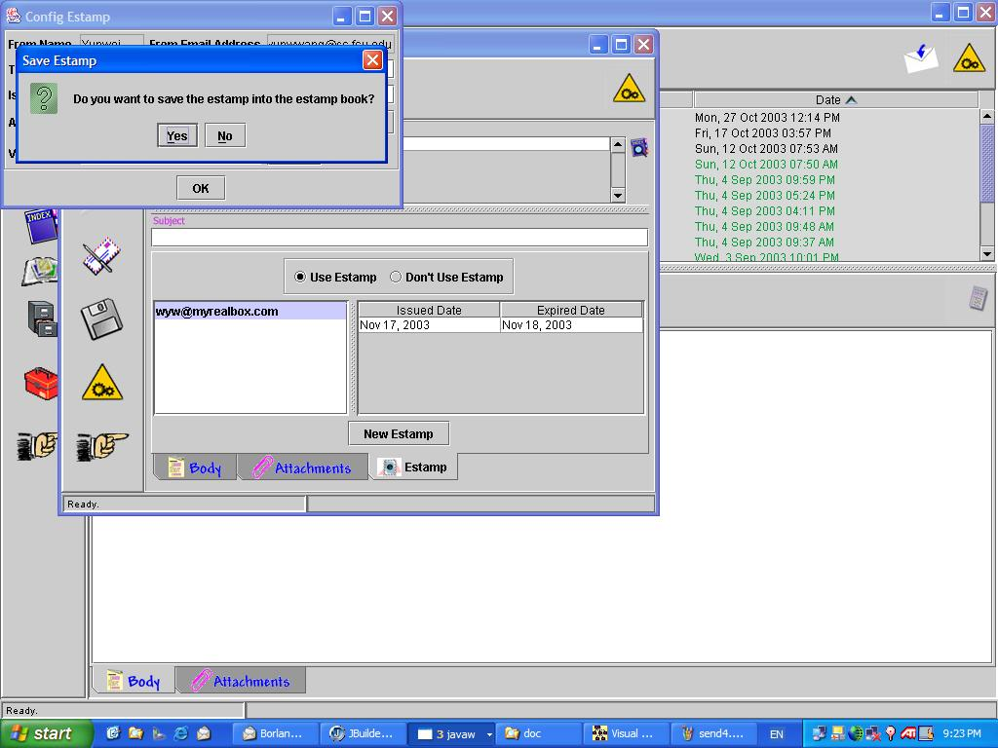
Figure 22: Select Option to save new eStamp for future reuse.

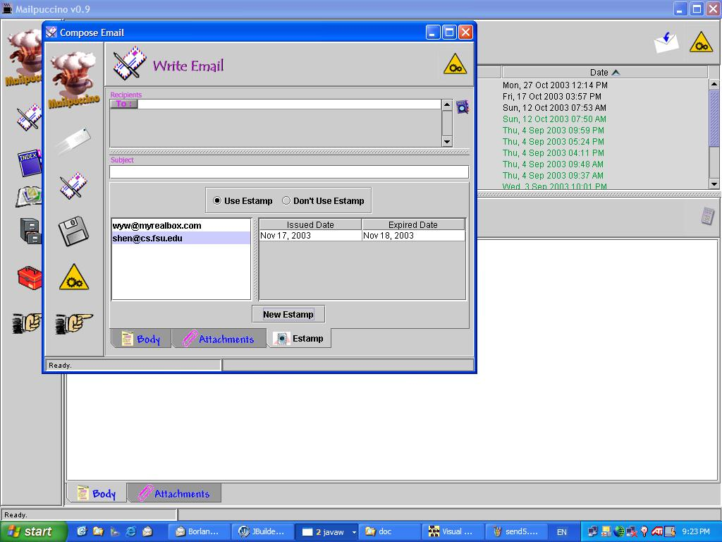
Figure 23: Client selects the appropriate eStamp to be used for the email.

eStampBook GUI Interface

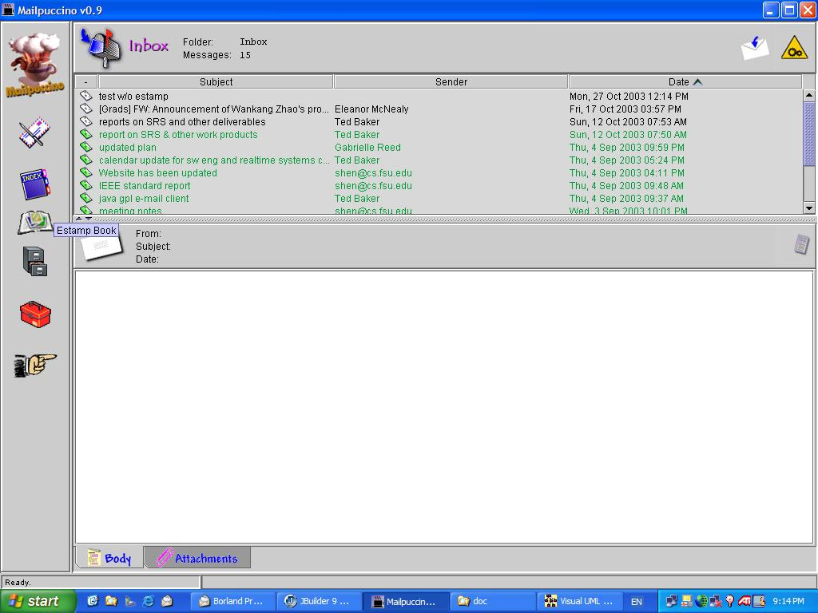
Figure 24: Clicking on the eStamp Book Icon on the first panel.
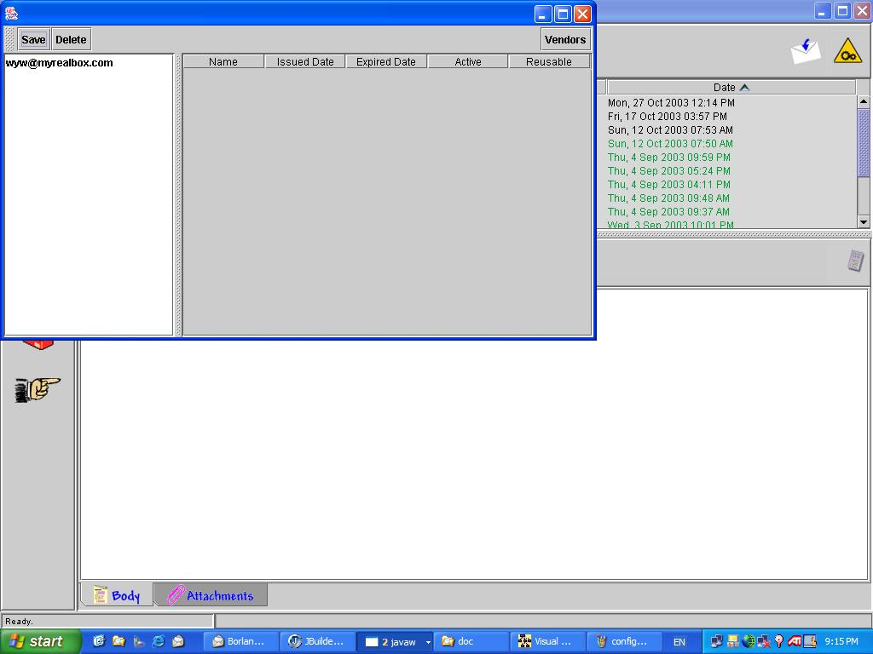
Figure 25: The eStampBook panel opens and displays eStamps in the list.

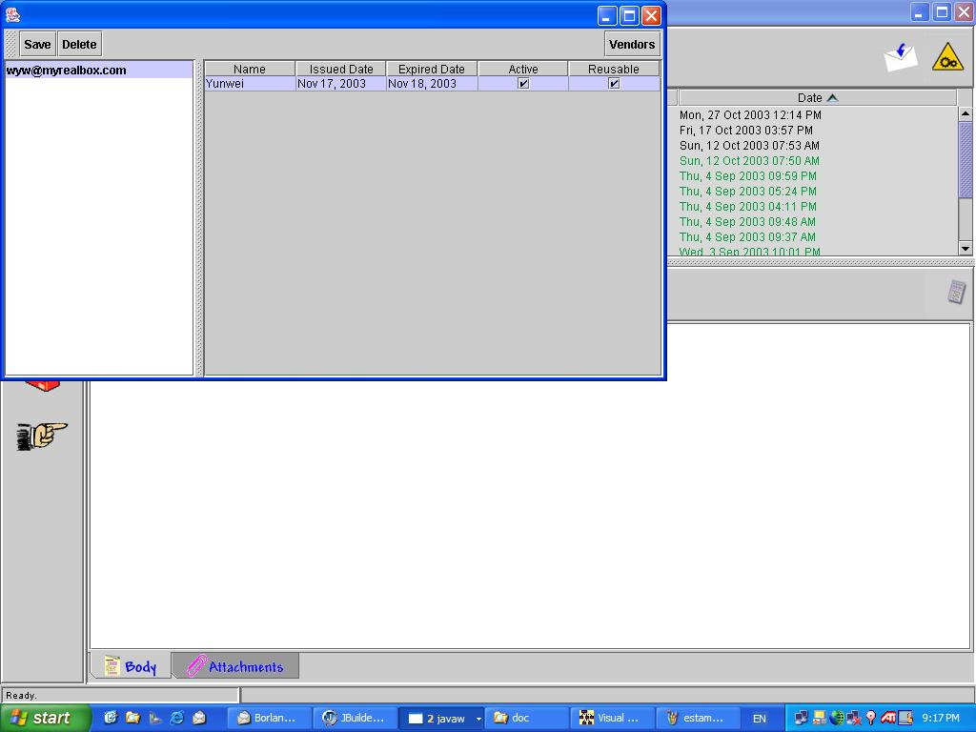
Figure 26: By Selecting an eStamp in the list, the panel displays the details of that eStamp.

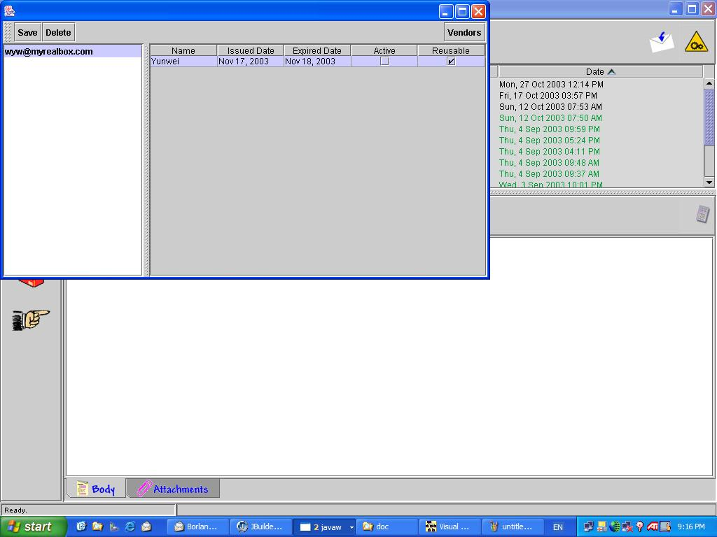
Figure 27: Active and Reusable State values of the eStamp can be changed.

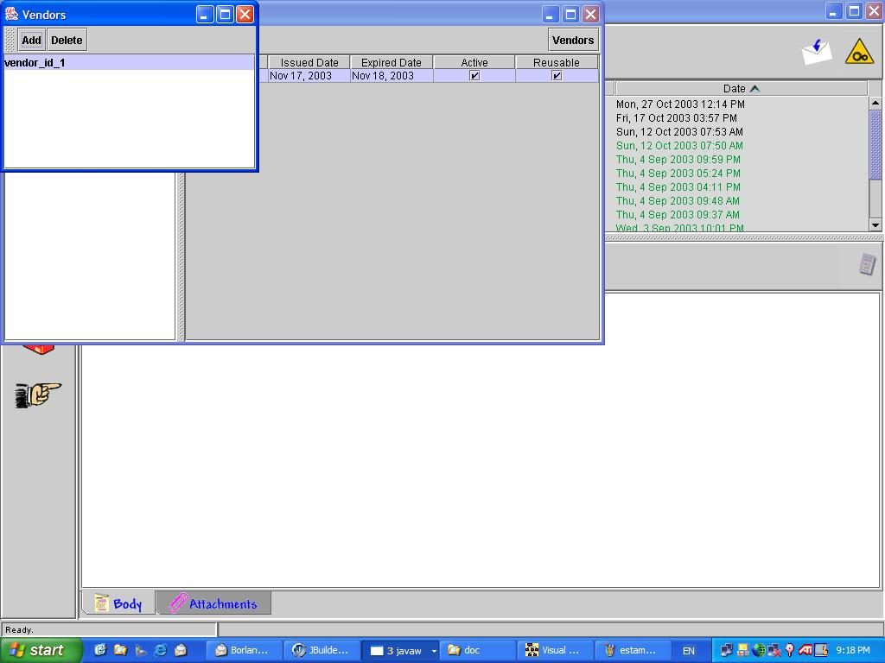
Figure 28: eStamp Vendors can be added or deleted from the Vendor List.

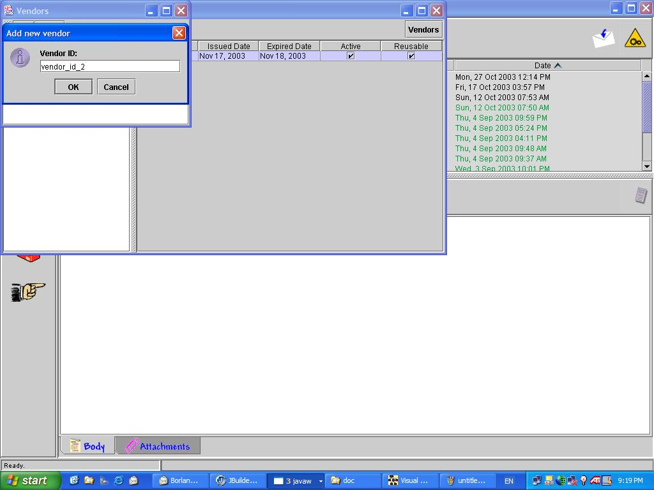
Figure 29: After clicking the Add button, enter the new vendor information.

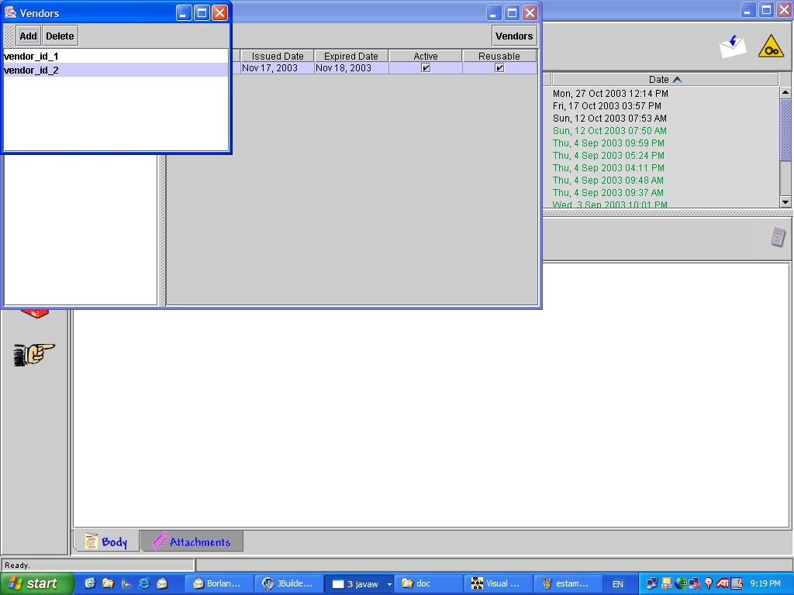
Figure 30: Selects Vendor list to see available vendors.

6. Detailed Design

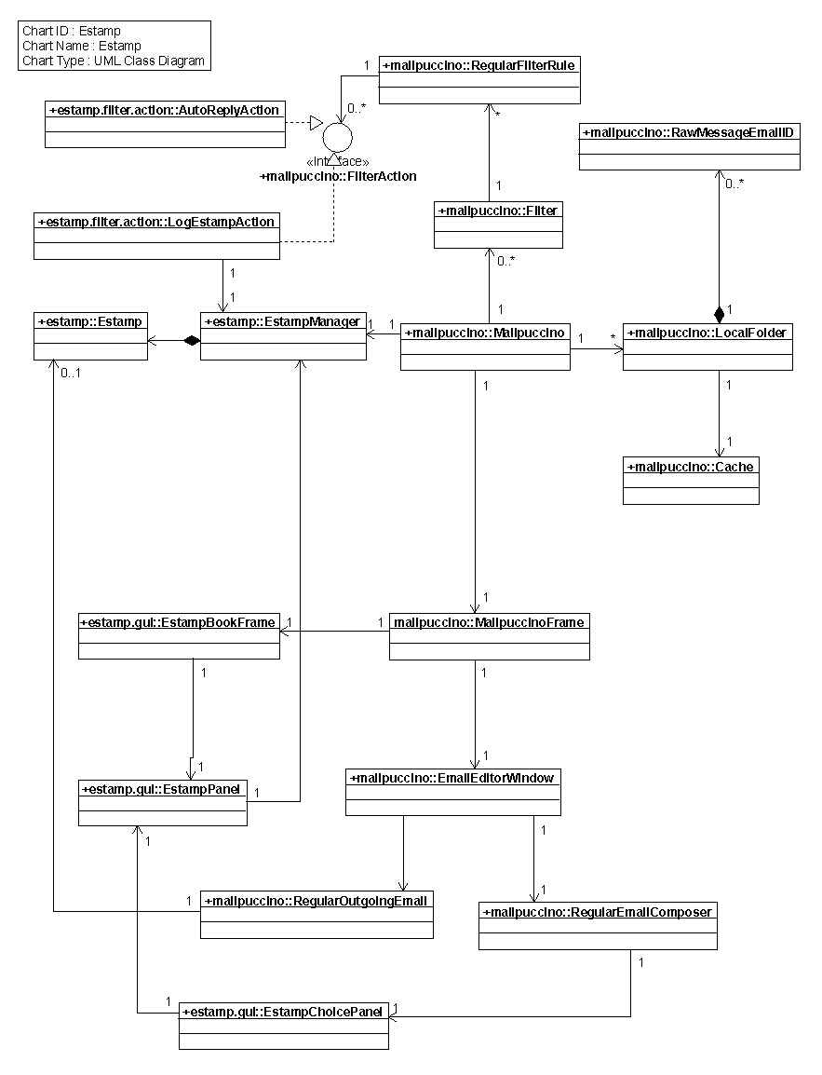

Appendix A: EStamp Package Class Source Listing and Documentation

Class eStampBook {

//Members
Panel eStampBookPanel;
Guid eStampID;
String purchaseInfo;
Guid filterRuleID;

//Methods
Boolean setInvoke( eStamp eStampID) { eStampID.setInvoke(); return true; }
setRevoke(eStamp eStampID) { eStampID.setRevoke(); return true; }
useEStamps( filterRuleID) { filterRuleID.setUseEStamps(); return true; }
setReusable(eStamp eStampID) { eStampID.setReusable(); return true; }
buyEStamps( String purchaseInfo)
{ vendor.connection( purchaseInfo); return true;}

}

class eStampBookPanel {
//Members
List eStampList;
eStamp eStampID;
checkbox invoke;
checkbox revoke;

//Methods

}

Appendix B EStamp

estamp
Class Estamp
public class Estamp
Title: Estamp.java
Description: Represents an estamp. The detailed information contains:
- the recipient's name and email address,
- the sender's name and email address,
- the vender's id,
- public-private key pair,
- the issued and expiation date of the estamp.
Copyright: Copyright (c) 2003
Company: segy
Version:
1.0
Author:
wyw

Field Detail

FROM_NAME
public static final int FROM_NAME

FROM_EMAIL
public static final int FROM_EMAIL

TO_NAME
public static final int TO_NAME

TO_EMAIL
public static final int TO_EMAIL

NAME
public static final int NAME

ISSUE_DATE
public static final int ISSUE_DATE

EXPIRE_DATE
public static final int EXPIRE_DATE

ACTIVE
public static final int ACTIVE

REUSABLE
public static final int REUSABLE

VENDOR_ID
public static final int VENDOR_ID

PUBLIC_KEY
public static final int PUBLIC_KEY

PRIVATE_KEY
public static final int PRIVATE_KEY

FIELDS
public static final java.lang.String[] FIELDS
Fields' name

m_fields
private java.lang.Object[] m_fields

Constructor Detail

Estamp
public Estamp()
Default constructor

Estamp
public Estamp(java.lang.Object[] fields)
Constructor with specific estamp fields
Parameters:
fields - estamp fields

Estamp
public Estamp(java.util.Vector fields)
Constructor with specific estamp fields
Parameters:
fields - estamp fields

Method Detail

encryptEstamp
public java.lang.String encryptEstamp()
Encrypt the estamp using key-pairs
Returns:

equals
public boolean equals(estamp.Estamp estamp)
Indicates whether some other estamp is "equal to" this one
Parameters:
estamp - the reference esta,p with which to compare.
Returns:
true if this object is the same as the obj argument; false otherwise

get
public java.lang.Object get(int index)
Gets one estamp field
Parameters:
index - the index of the field
Returns:
the estamp field

getFields
public java.lang.Object[] getFields()
Get all estamp fields
Returns:

init
public void init()
Initialize estamp fields

isValid
public boolean isValid()
Determin whether the estamp of an email is a valid estamp.
Returns:
true if the estamp is a valid estamp. false if the estamp is invalid.

set
public void set(int index,
java.lang.Object field)
Sets one estamp fields
Parameters:
index - the index of the field
field - the value of the field

setFields
public void setFields(java.lang.Object[] fields)
Resets all the estamp fields
Parameters:
fields -

Appendix C: EStamp Vendor

Prototype Client Side Vendor Service code
import java.io.*;
import java.net.*;
public class getEStamp {
public static void main(String[] args) throws Exception {
if (args.length != 1) {
System.err.println("Usage: java getEStamp " + "string_to_convert_to_stamp");
System.exit(1);
}
/** shen@cs.fsu.edu&from=shen@cs.fsu.edu&issue=11/21/03&expire=11/25/03&reuse=yes
String stringToEncrypt = URLEncoder.encode(args[0]);
URL url = new URL("http://saint.coe.fsu.edu/newmimic/vendor/geteStamp.cfm");
URLConnection connection = url.openConnection();
connection.setDoOutput(true);
PrintWriter out = new PrintWriter( connection.getOutputStream());
out.println("?to=" + stringToEncrypt);
out.close();
BufferedReader in = new BufferedReader(
new InputStreamReader(
connection.getInputStream()));
String inputLine;
while ((inputLine = in.readLine()) != null)
System.out.println(inputLine);
in.close();
}
}
or just to send the information as a URL and read:
--------------------
import java.net.*;
import java.io.*;
public class URLConnectionReader {
public static void main(String[] args) throws Exception {
URL vendor = new URL("http://saint.coe.fsu.edu/newmimic/vendor/geteStamp.cfm?to=shen@cs.fsu.edu&from=shen@cs.fsu.edu&issue=11/21/03&expire=11/25/03&reuse=yes");
URLConnection yc = vendor.openConnection();
BufferedReader in = new BufferedReader(
new InputStreamReader(
yc.getInputStream()));
String inputLine;
while ((inputLine = in.readLine()) != null)
System.out.println(inputLine);
in.close();
}
}

Class Description

EstampVendor
Class eStampVendor

public class eStampVendor
eStamp vendor main class

registerAccount
public boolean registerAccount(java.lang.String email,
java.lang.String login,
java.lang.String password,
java.lang.String address,
int cardType,
java.lang.String cardnum,
java.util.Calendar expDate)
Register stamp buyer account

login
public java.lang.String login(java.lang.String login,
java.lang.String password)
Identify the client in the system; get session cookie

getStamp
public java.lang.String getStamp(java.lang.String cookie,
java.lang.String receiverAddress)
Buy stamp

EstampVendor
Class RSA
public class RSA
implements EstampVendor.EncryptionInterface
Cryptography functions

Encrypt
public java.lang.String Encrypt(java.lang.String message,
java.lang.String privkey)
To encrypt

Decrypt
public java.lang.String Decrypt(java.lang.String message,
java.lang.String pubkey)
To decrypt

EstampVendor
Class AccountManager
public class AccountManager
Account management class

Validate
public boolean Validate(int cardType,
java.lang.String cardnum,
java.util.Calendar expDate)
Validate credit card

registerAccount
public void registerAccount(EstampVendor.Account acc)
Register customer account in the database

getAccount
public EstampVendor.Account getAccount(java.lang.String login,
java.lang.String password)
get account

Appendix D: eStamp Manager

estamp
Class EstampManager
public class EstampManager
Title:
Description:
Copyright: Copyright (c) 2003
Company: segy
Version:
1.0
Author:
y.w.
Field Detail

m_estamps
private java.util.Hashtable m_estamps

m_publicKey
private static java.lang.String m_publicKey

m_privateKey
private static java.lang.String m_privateKey

m_vendorIDs
private static java.util.Vector m_vendorIDs

Constructor Detail

EstampManager
public EstampManager()
Default constructor.

Method Detail

addEstamp
public void addEstamp(estamp.Estamp estamp)
Adds a new estamp into the hashtable
Parameters:
estamp - the estamp to be added

addEstamp
public void addEstamp(java.lang.Object key,
estamp.Estamp estamp)
Adds a new estamp into the hashtable
Parameters:
key - the key of the estamp
estamp - the estamp to be added

clear
public void clear()
Clears this hashtable so that it contains no keys and no estamps.

getEstamps
public java.util.Vector getEstamps(java.lang.Object key)
Gets the estamps to which the specified key is mapped in this hashtable
Parameters:
key - the key whose associated estamps are to be returned.
Returns:
the vector of estamps to which this map maps the specified key, or null if the map contains no mapping for this key.

getHostEmail
static java.lang.String getHostEmail()
Gets the host's email address
Returns:
the host email address

getHostName
static java.lang.String getHostName()
Gets the host's name
Returns:
the host's name

getKeys
public java.lang.Object[] getKeys()
Gets the keys of the estamps contained in this hashtable. The key of an estamp is the sender's email address.
Returns:
an array of the keys

getSelectedEstamp
public estamp.Estamp getSelectedEstamp(java.lang.Object key,
int index)
Gets the selected estamp in the EstampPanel
Parameters:
key - the key of the hashtable
index - the selected estamp
Returns:

getVendorID
static java.lang.String getVendorID(int index)
Gets the vendor id specified by index
Parameters:
index - the index of vendor id
Returns:
the vendor id

getVendorIDs
public static java.util.Vector getVendorIDs()
Gets all vendor ids
Returns:
vendor ids

loadEstamp
public void loadEstamp()
Loads estamps from data file, which is saved in XML format

remove
public java.util.Vector remove(java.lang.String key)
Removes the key (and its corresponding estamps) from this hashtable. This method does nothing if the key is not in the hashtable.
Parameters:
key - the key that need to be removed
Returns:
a vector of estamps that the key has been mapped in this hashtable, or null if the key did not have a mapping

removeExpriredEstamps
private void removeExpriredEstamps()
Removes expired estamps

saveEstamps
public void saveEstamps()
Saves estamps to a data file, which is in XML format

setEstamp
public void setEstamp(java.lang.Object key,
java.util.Vector newEstamps)
Maps the specified key to the specified value in this hashtable. Neither the key nor the value can be null. If the key has mapped with a estamps vector, compare the current estamps with the new estamps and applies the differences.
Parameters:
key - the hashtable key.
newEstamps - the vector of estamps

size
public int size()
Gets the number of key-estamp mappings in this hashtable.
Returns:
the number of key-value mappings in this hashtable.

testing
private void testing()
Creates an sample estamp for testing

