Creating GUI’s in your Environment
For your HCI Prototype
For Full Project GUIs

We will be using the following environment
IDE - ECLIPSE (free, heterogeneous and expandable)
JIGLOO – GUI interface (free, easy to use)
DERBY – Database System (free, easy to use)

CREATING a JIGLOO (GUI INTERFACE)

1. Assure Environment

Make sure you have set up your environment as prescribed.

2. Open Eclipse

2a. Open the Eclipse IDE
2b. Select the Java Perspective by selecting
Window
Show Perspective
Java
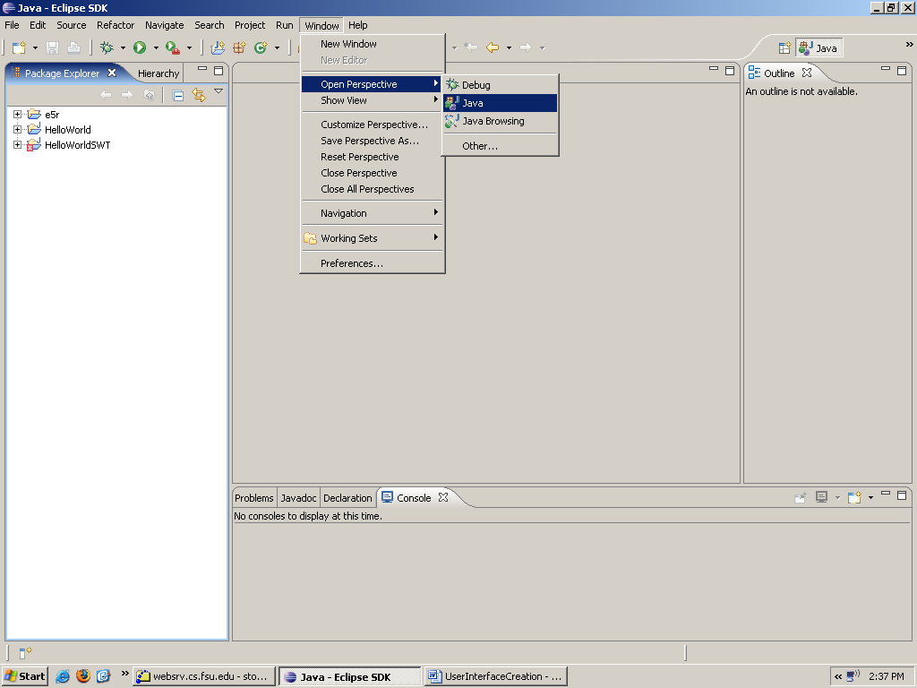

3. Select or Create a Project
3a. Select and existing project
Window
Show View
Package Explorer
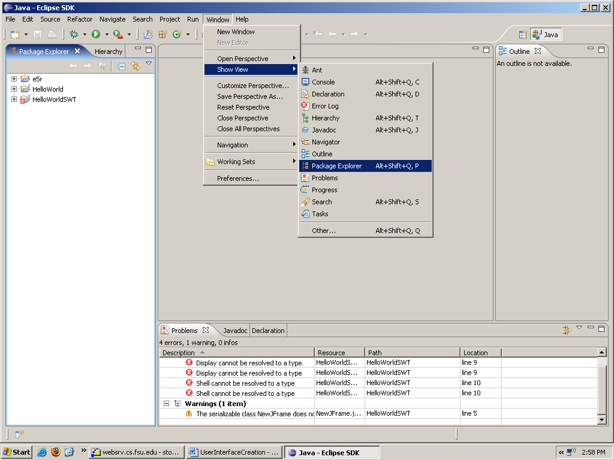

You will then see the projects

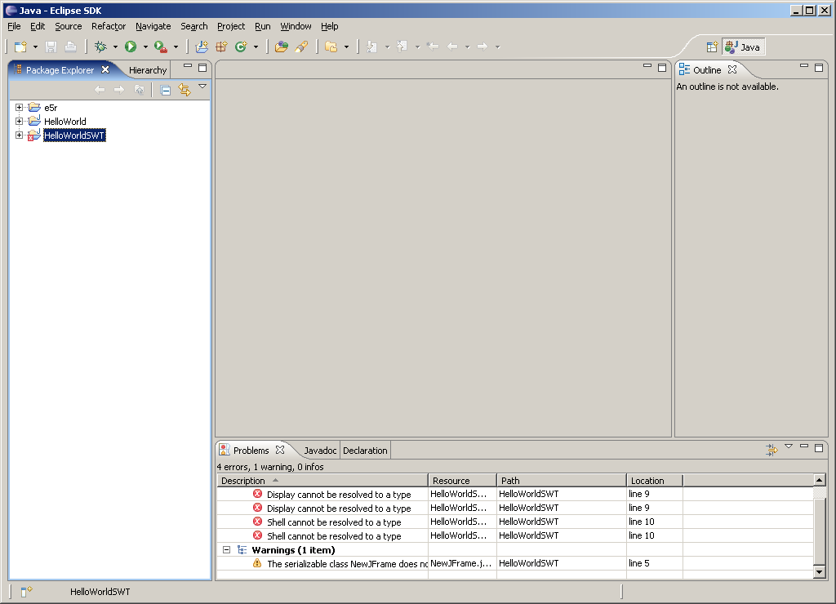

3 b. Create A Project
File
New Project

4. Open the Jigloo Forms Development
4 a. Select
File
New
Other THEN GUI Forms

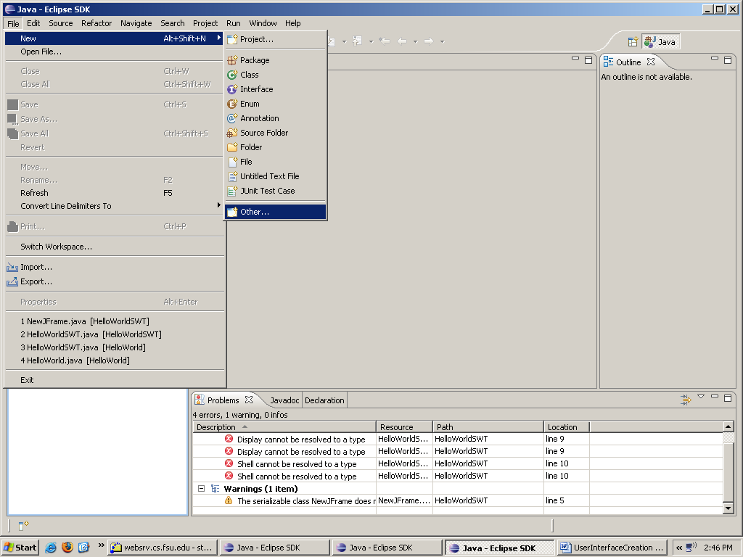

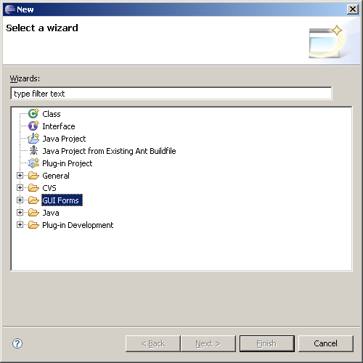

5. Select the Jigloo Forms Development JFrame
5 a. WITH A PROJECT SELECTED (new or existing)
Select
File
New
Other
GUI Forms
Swing
JFrame
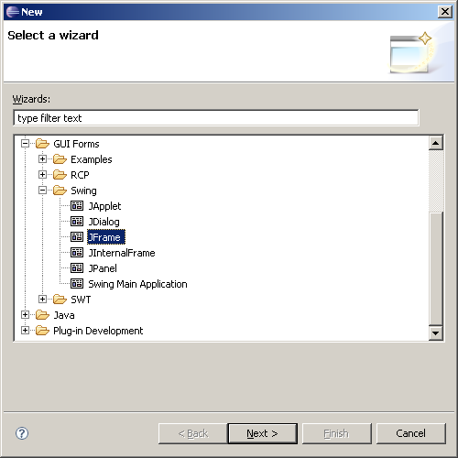

Then Click Next Finish OK

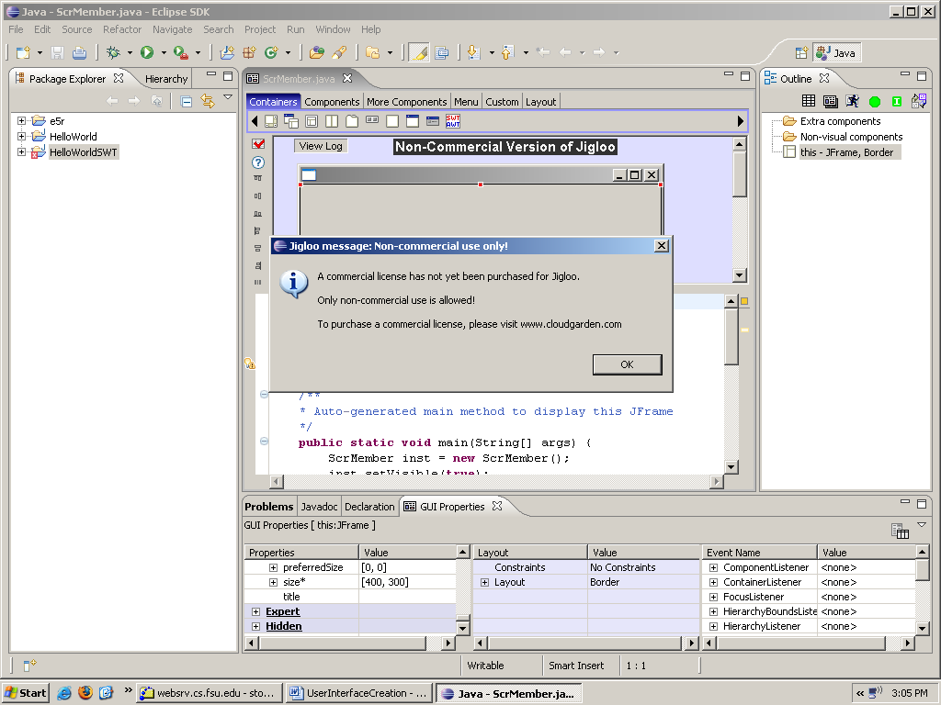

6. You are now ready to build your GUI Class
6 a. Set your layout to absolute

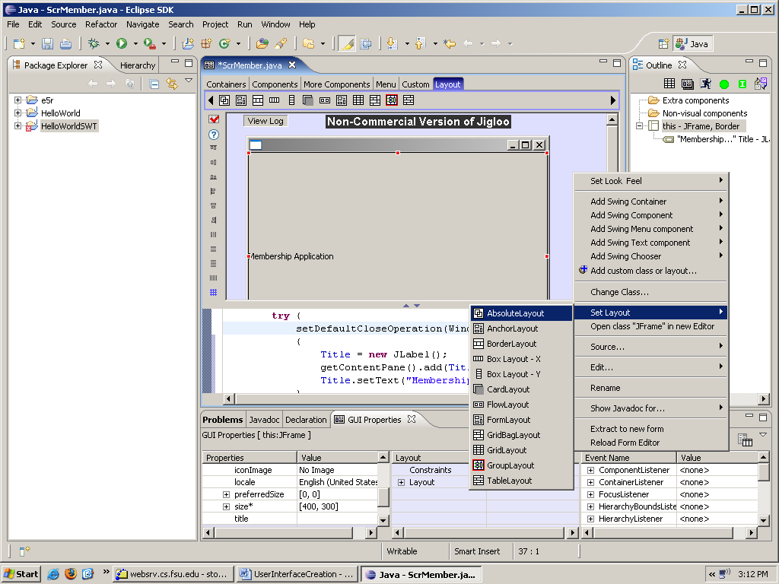

6 b. Drag and drop components from the top of the screen
They will generate code in the lower half.

FOR LABELS you will NOT need get and set methods
FOR TEXTFIELDS you WILL need get and set methods
Make sure you click to have the gets and set methods.

7. Testing your Use Case Screens.
To test your screens build a Use Case class which simply displays the screens.
It will look something linke the following:

public class UCRegisterasMember {

/**
* @param args
*/
ScrMember scrMember;
public static void main(String[] args) {
// TODO Auto-generated method stub
ScrMember scrMember = new ScrMember();
scrMember.setVisible(true);
System.out.println ("I just displayed the Member Screen");
}
}

8. Some helpful hints

The main screen of each use case should be a JFrame
Other subscreens displayed on a main screen may be a JPanels.
Make sure you set your layout to absolute
DO NOT PLACE any navigational controls in these classes.
DO NOT PLACE a main in the user interfaces.
Place the main in the Use Case Controller

