Creating GUI’s in your Environment
For your HCI Prototype
For Full Project GUIs

We will be using the following environment
IDE - ECLIPSE (free, heterogeneous and expandable)
JIGLOO – GUI interface (free, easy to use)
DERBY – Database System (free, easy to use)

The Focus of this lecture is JIGLOO for creating a GUI user interface.

For Software Engineering One, we will only be creating the GUIs with no navigations.

For Software Engineering Two – Navigations will be added.

Your assignment is to create ALL the GUI interfaces you need to process the use cases. You will want to divide up the responsibilities of each of these interfaces among your team members. Make sure your minutes and/or project plan contain the name of the user interface, the use case(s) it is associated with and the person assigned.

Each team member should place the files they were responsible for in a zip file. Then post the location of the zip files on your main web site

You can export classes from your environment.
CREATING A JIGLOO (GUI INTERFACE)

1. Assure Environment

Make sure you have set up your environment as prescribed.

2. Open Eclipse

2a. Open the Eclipse IDE
2b. Select the Java Perspective by selecting
Window
Open Perspective
Java
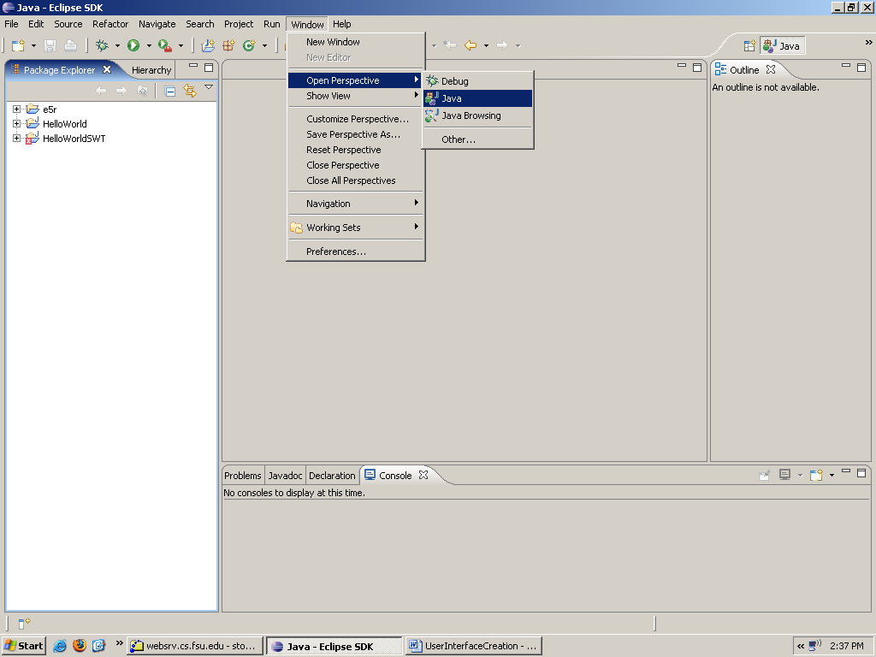

3. Select or Create a Project
Everything MUST be under a project. So if you have never created a project, you will need to do so.
If you have created a project you may View the existing projects with the following commands.

3a. View existing Projects
Window
Show View
Package Explorer
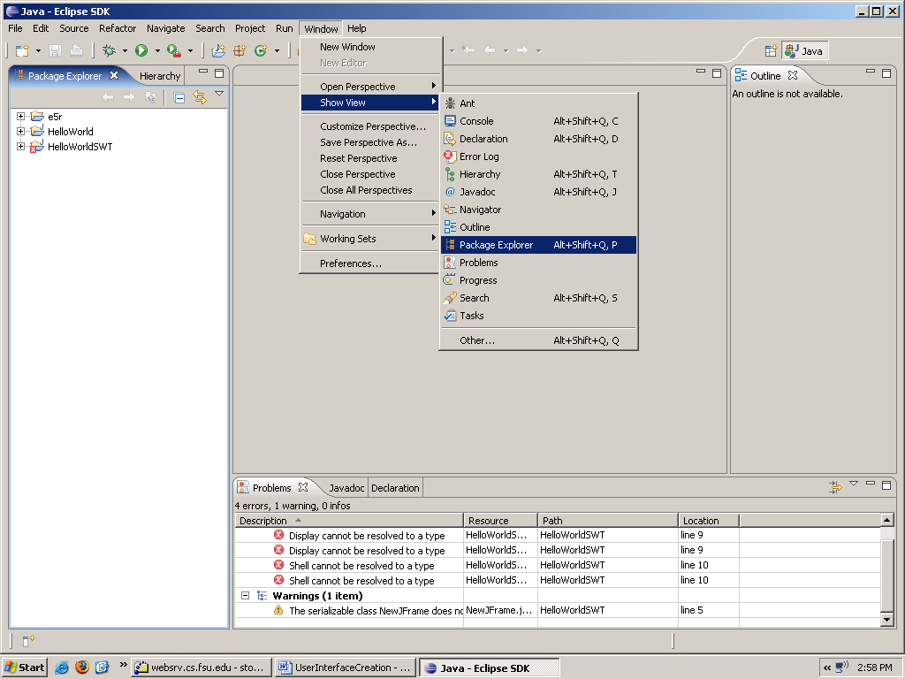

You will then see the projects

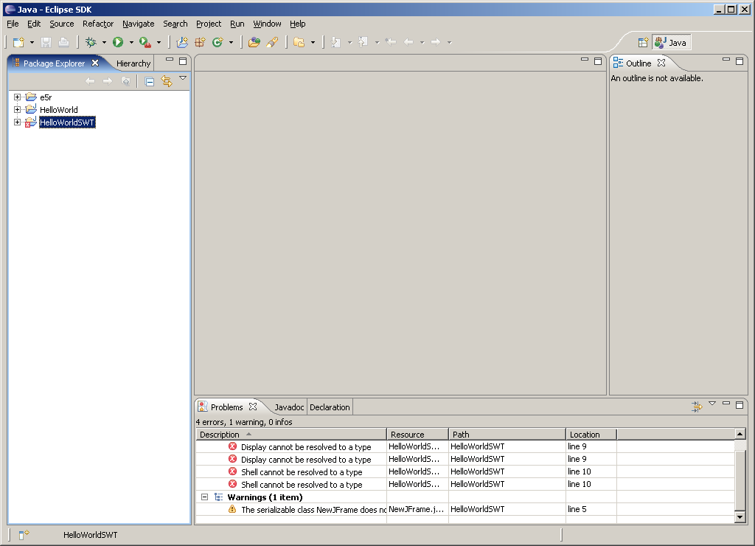

3 b. EITHER Select a Project
Click on Project shown from tasks above.

OR Create A New Project
File
New
Java Project
Enter a name for your project (your team project)

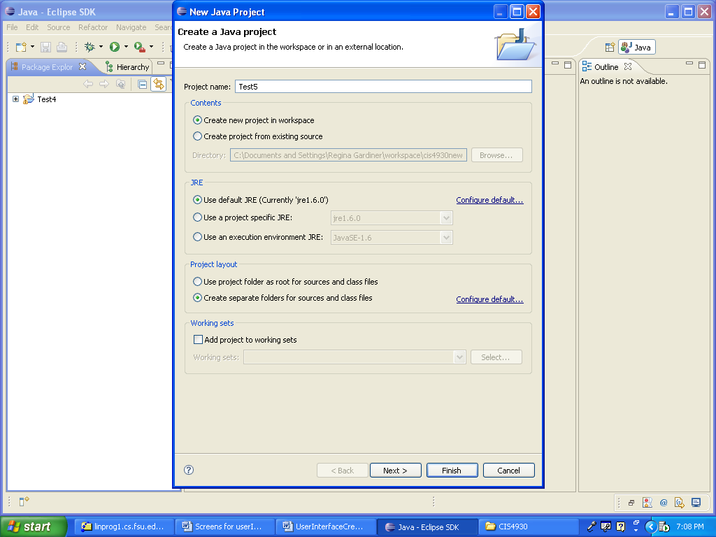

4. Select or Create a Package

All items should be under a package.

How you define your packages is up to you.

You can view the packages under the package explorer.

4a. EITHER Select a Package
Click on Package

OR Create A New Package
File
New
Java Package

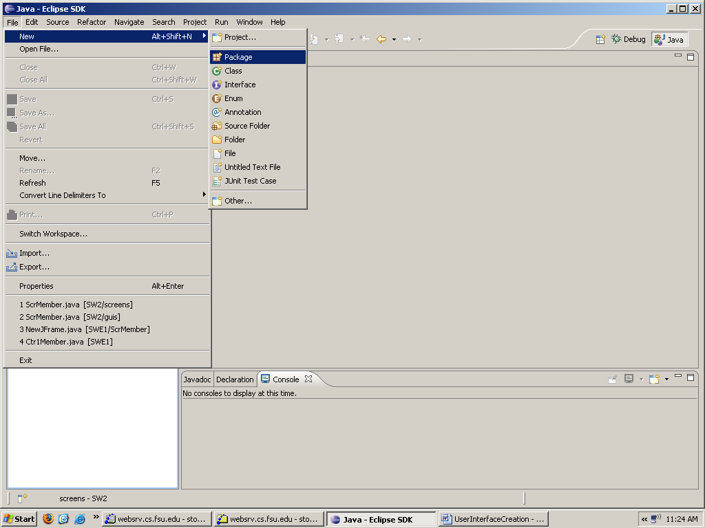

4b. Name the Package

Names of packages are usually lower case.

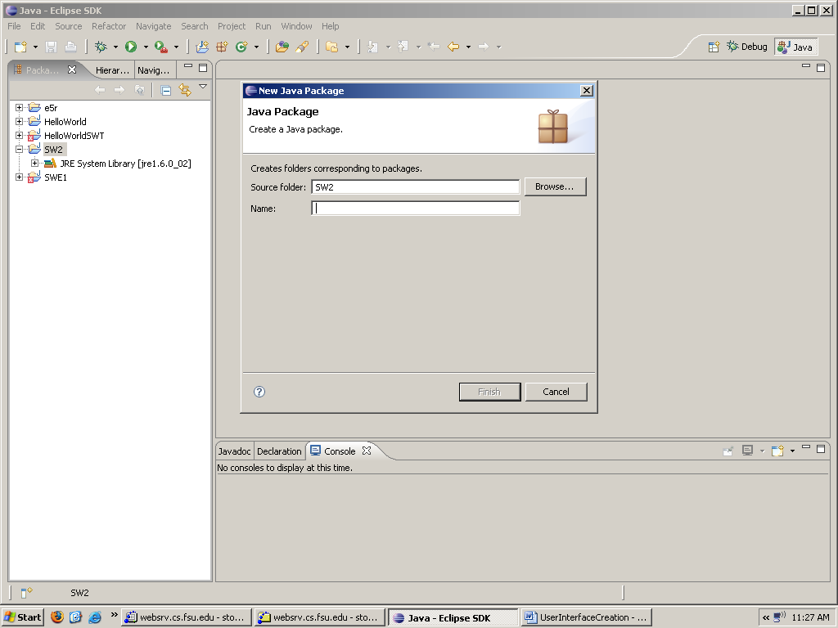

5. Add your Forms
5 a. Select the Jigloo Forms Development JFrameWI
WiTH A PROJECT AND PACKAGE SELECTED (new or existing)
5 b. Select the Forms Development Environment BY:
Select File
Select New
Select Other:
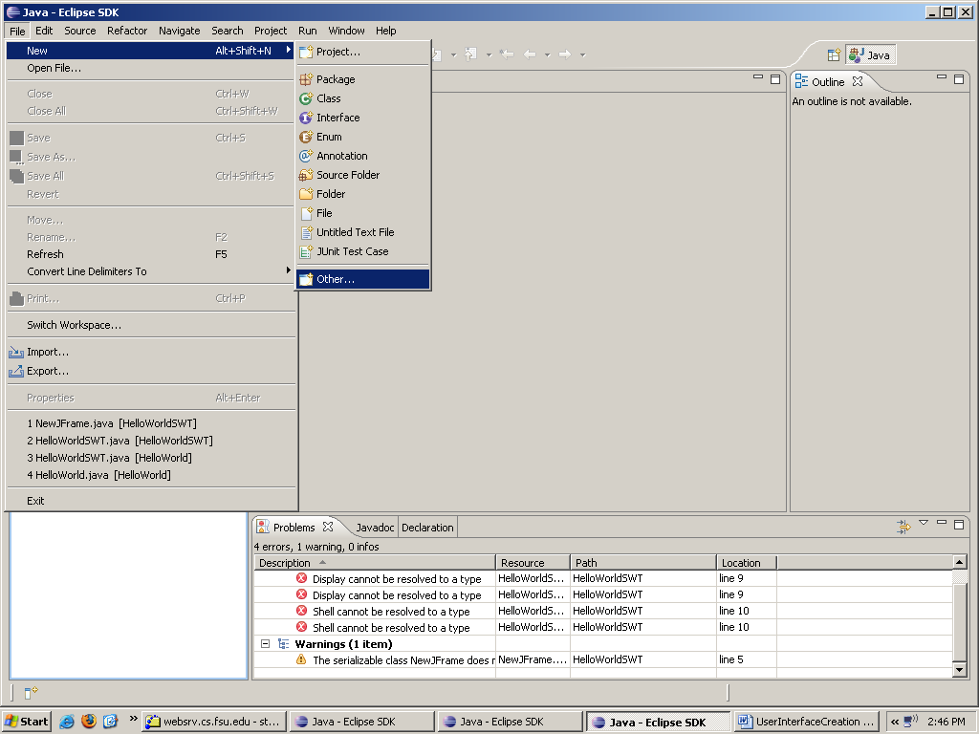

Then Select GUI Forms

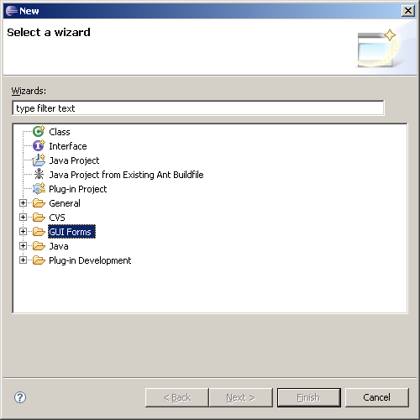
Then under Swing, Select JFrame
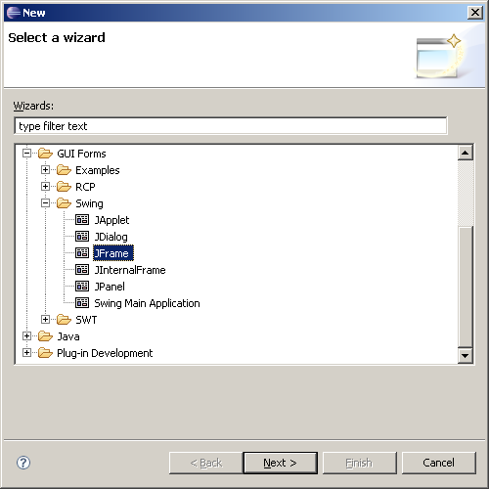

Enter the name of your screen NOTE: the standard is Scrxxxx.
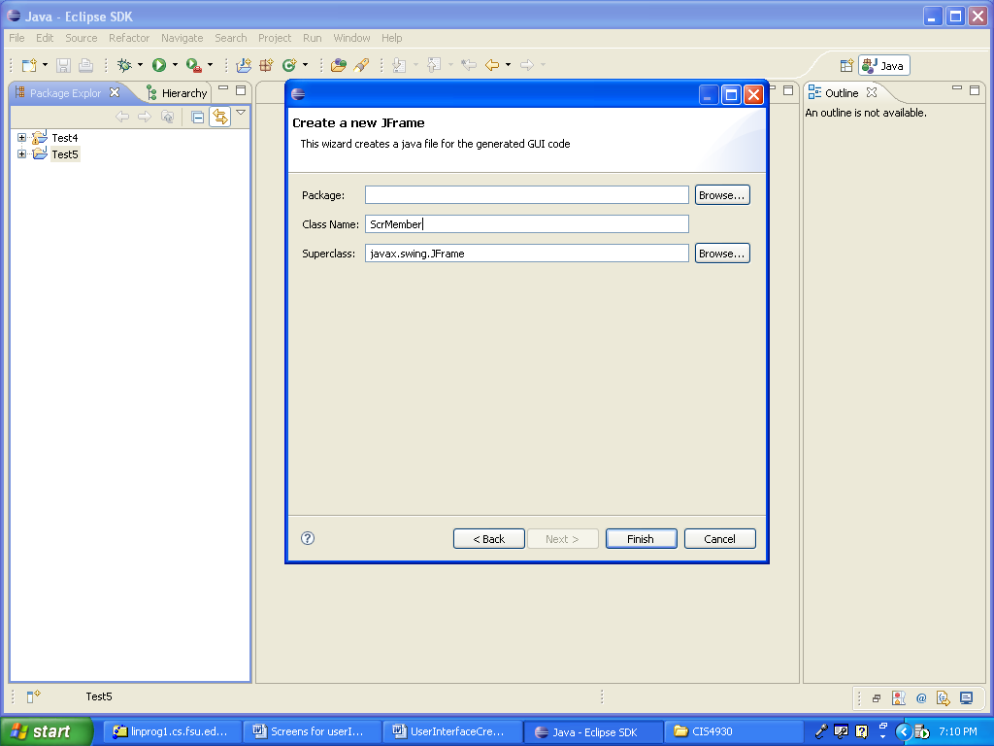
YOUR Screen NAME

Then, Finish OK

The following screen will appear.
And beneath the Jigloo framework, a class has been created with the name of the screen.
You will notice the code beneath the screen.

YOU ARE NOW READY to BUILD YOUR GUI SCREEN

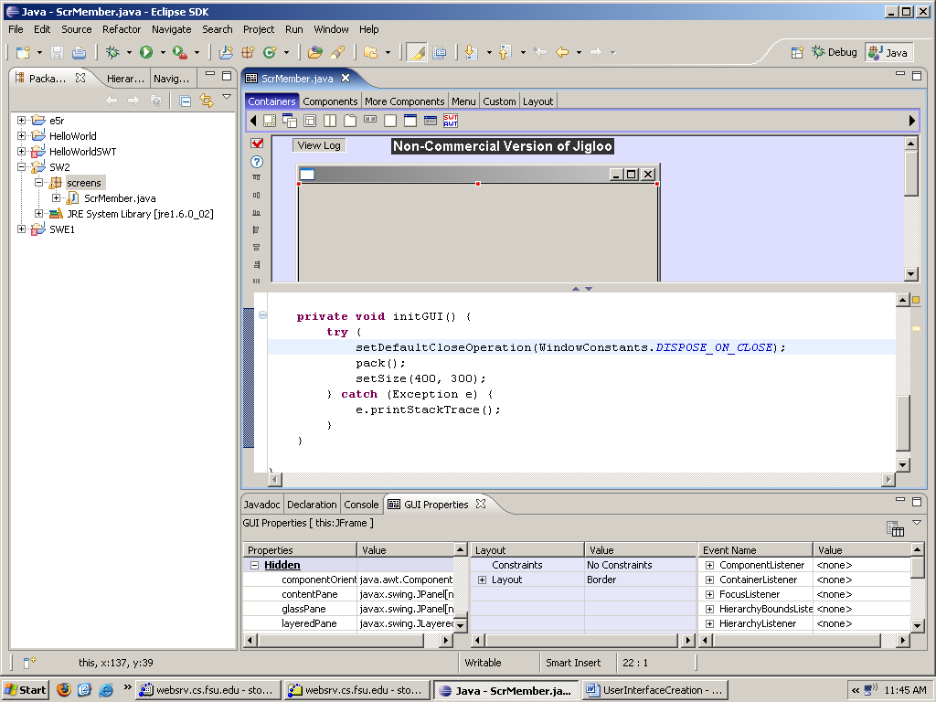

5. Building your Graphical User Interface (GUI) Class
5 a. Set your layout
The following will set the layout to Anchor Layout.
You can choose the layout that best fits your screen design.
Choose Layout,
Choose AnchorLayout icon,
Then click on the screen form itself.

The following code will appear: 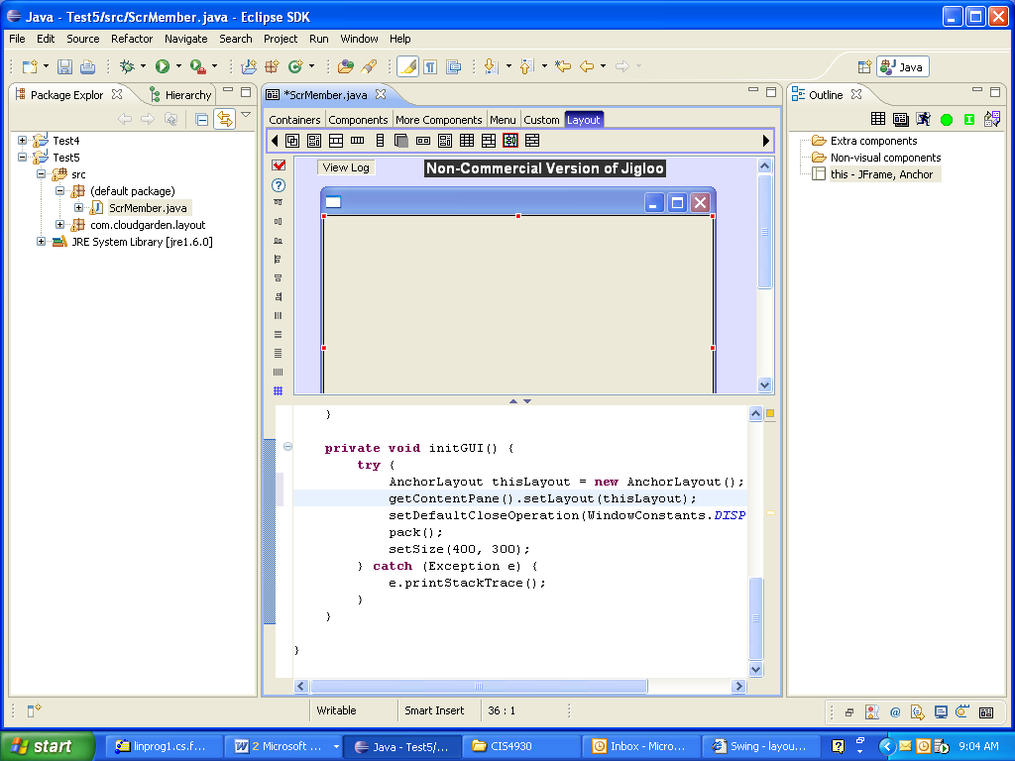

Or To do the same thing:

Right Click anywhere on your GUI form

The Set Look and Feel Menu will pop up.

Choose Set Layout, AnchorLayout.

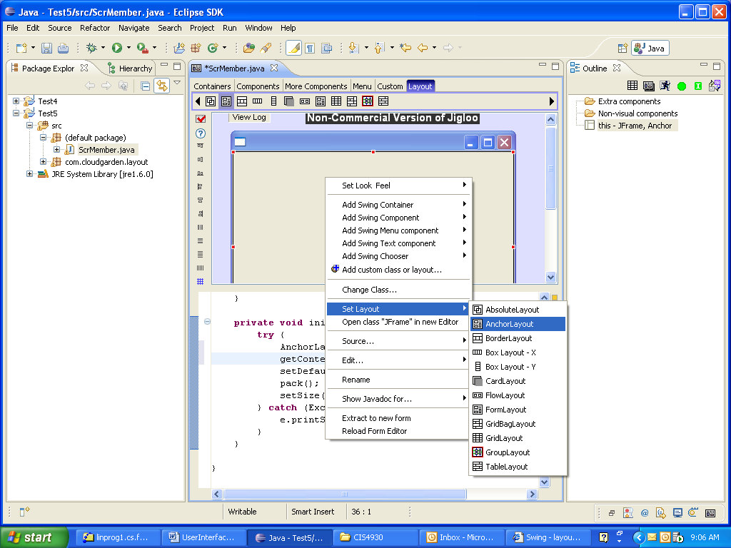
6 b. ADD COMPONENTS TO FRAME

Maximize your form screen to see all parts of the form.
Choose either the Components or More Components tab to see component choices.

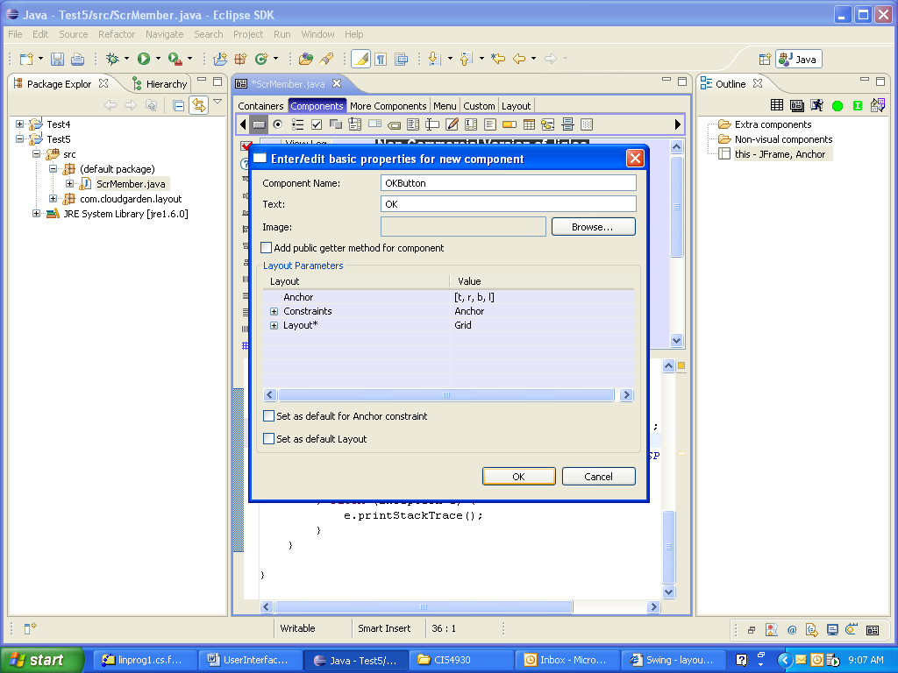

Drag and drop components from the top of the screen
They will generate code in the lower half.
