Project Planning

Project Planning
Once the initial project initiation is completed, the project team, usually the project manager and the analysts in the early stages, must determine the scope of the effort necessary to accomplish the necessary tasks. There are many methods available for accomplishing this planning process; many of them use graphics of varying types, but all require the same basic information.
- Project start date
- Project completion date
- Selection of the project methodology or project life cycle to be used
- Scope of the project in terms of the phases of the selected project methodology or project life cycle.
- Identification or selection of the project review methods to be used
- Identification of any predetermined interim milestone or other critical dates which must be met.
- A list of tasks, by project phase in the order in which they must be accomplished
- An estimate of the personnel necessary to accomplish each task
- An estimate of the personnel available to accomplish each task
- Skill level necessary to perform each task
- Task dependencies
- Which tasks can be performed in parallel
- Which tasks require the completion of other tasks beforethey can start<
- Project control, or review points<
- Project cost estimation and cost-benefit analysis
There are several techniques available that can help you put together a project schedule and work plan that will prove helpful during the development cycle. One of those is the Work Breakdown Structure (WBS). This is a business related diagram that allows management to understand the tasks you plan to do in this effort so they can get some idea of the effort involved.
Work Breakdown Structures (WBS)
The development of a project plan is predicated on having a clear, and detailed understanding of both the tasks involved, the estimated length of time each task will take, the dependencies between those tasks, and the sequence in which those tasks have to be performed. Additionally, resource availability must be determined in order to assign each task or group of tasks to the appropriate worker.
One of the methods used to develop the list of tasks is to create what is known as a Work Breakdown Structure (WBS).
A definition
A Work Breakdown Structure (WBS) is a hierarchic decomposition or breakdown of a project or major activity into successively levels, where each level is a finer breakdown of the preceding one. In final form a WBS is very similar in structure and layout to a document outline. Each item at a specific level of a WBS is numbered consecutively (e.g. 10, 20, 30, 40, 50). Each item at the next level is numbered within the number of its parent item (e.g. 10.1, 10.2, 10,3, 10.4)
The WBS may be drawn in diagrammatic form (if automated tools are available) or in a chart form resembling an outline.
The WBS begins with a single overall task representing the totality of work to be performed on the project. This becomes the name of the project plan WBS
Using a methodology or system life cycle steps as a guide, the project is divided into its major steps. In our case we will use the Unified Process phases. Each of these phases must be broken down into their next level of detail, and each of those, into still finer level of detail, until a manageable task size is arrived at. The first level of Work Breakdown Structure for the unified process is illustrated in Table 6.1
Tasks at each successively finer level of detail are numbered to reflect the task from which they were derived. Thus the first level of tasks would be numbered 1.0, 2.0, 3.0, and so forth. Each of their sub-tasks would have a two part number. The first part reflecting the parent task and the second part being the sub-task number itself e.g. 1.1, 1.2, 1.3, etc. As each of these is in turn decomposed or broken down into their component tasks, the components receive a number comprised of its parent’s number plus a unique number of its own.
A Definition:
A manageable task is one where the expected results can be easily identified, success, failure, or completion of the task can easily be ascertained, the time to complete the task can easily be estimated, and the resource requirements of the task can easily be determined.

WBS Number | Task Description
1.0 | Inception
1.1 | Draft Project Plan
2.0 | Elaboration
2.1 | Plan UserInterviews
2.2 | Schedule UserInterviews
3.0 | Construction
4.0 | Transition
Table 6.1 First level of Work Breakdown Structure for the life cycle
Planning Methods
There are various methods for generating the project plan. Some of the most widely used are discussed below.
PERT-project evaluation and review technique
PERT charts depict task, duration, and dependency information. Each chart starts with an initiation node from which the first task, or tasks, originates (Figure 6.1). If multiple tasks can begin at the same time, they are all started from the node and branch, or fork out from the start point.
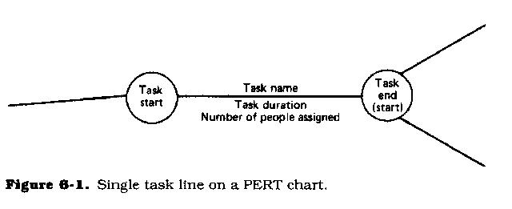
The Figure above is an example but on Page 96 of your text is a better example of a PERT chart. Either example will be acceptable for submission.
Each task is represented by a line which states its name or other identifier, its duration, the number of people assigned to it, and in some cases the initials of the personnel assigned. The other end of the task line is terminated by another node which identifies the start of another task, or the beginning of any slack time. Slack time is waiting time between tasks.
Each task is connected to its successor tasks in this manner forming a network of nodes and connecting lines. The chart is complete when all final tasks come together at the completion node. Where slack time exists between the end of one task and the start of another, the usual method is to draw a broken, or dotted line between the end of the first task and the start of the next dependent task.
A PERT chart (Figure 6.2) may have multiple parallel or interconnecting networks of tasks. Where the project has scheduled milestones, checkpoints, or review points (all of which are highly recommended in any project schedule), the PERT chart will note that all tasks up to that point terminate at the review node.
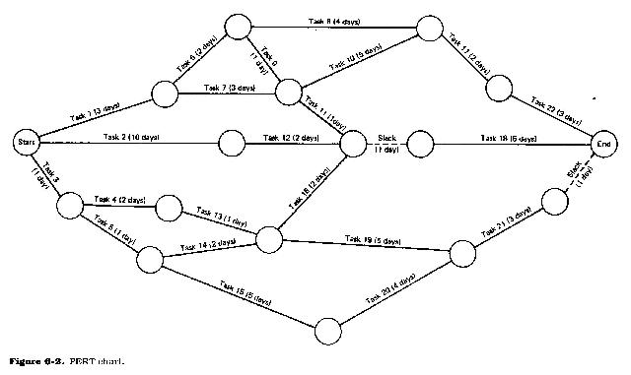
It should be noted at this point that project review, approvals, user reviews, etc., all take time. This time should never be underestimated when drawing up the project plan. It is not unusual for a review to take a week or even two. Obtaining management and user approvals may take even longer.
When drawing up the plan, be sure to include tasks for documentation writing, documentation editing, project report writing and editing, and report reproduction. These tasks are usually time consuming so don't underestimate how long it will take to complete them.
PERT charts are usually drawn on ruled paper with the horizontal axis indicating time period divisions in days, weeks, months, etc. Although it is possible to draw a PERT chart for an entire project, the usual practice is to break the plans into smaller, more meaningful parts. This is very helpful if the chart has to be redrawn for any reason, such as skipped or incorrectly estimated tasks.
Many PERT charts terminate at the major review points, such as at the end of the analysis stage or even at the end of the feasibility analysis. Many organizations include funding reviews in the project life cycle. Where this is the case, each chart terminates in a funding review node.
Funding reviews can affect a project in that they may either increase funding, in which case more people may be made available, or they may decrease funding, in which case fewer people may be available. Obviously more or less people will affect the length of time it takes to complete a project.

