YOUR Software Engineering ENVIRONMENT

We will be using a different environment for this course. To do projects of the size and nature needed for this course, we need a state of the art Interactive Development Environment with integrated components such as a
usable GUI interface,
acceptable database connection,
language compiler,
and interactive development environment (IDE).

The environment defined for your use in this course can be placed on your own computer. The instructions are in the next few sections. The components are as follows:

IDE - ECLIPSE (free, heterogeneous and expandable)

JIGLOO – GUI interface (free, easy to use)
DERBY – Database System (free, easy to use)

Eclipse has hundreds and hundreds of free plugins. It has language copilers (C, C++, Java, Ruby, Eiffle, Smalltalk, version of Ada, Object Pascal (whew), etc., refactoring tools, UML tools, upper CASE, lower CASE, code validators, pattern searchers, code structuring tools, performance evaluators, etc. It is slick slick slick. Free plugin can be found at various places. Just Google “Free Plugin ECLIPSE”. Here are a few that were up today but everyday new people are setting up sites with more and more items. The first two links have the standard things. Alphaworks changes often. New innovative software is placed on this site and often vendors buy the rights to the software and enhance it for a marketable product. So check it often to get neat software.

http://www.eclipseplugincentral.com/

Plugins for Eclipse
www.alphaworks.ibm.com

Below are the instructions for creating your environment. You will not need it right away but I thought I would let you get it set up in case you have any problems.

CREATING THE ECLIPSE ENVIRONMENT
WITH JIGLOO (GUI INTERFACE)
AND DERBY (SQL DATABASE)

1. DOWNLOAD NECESSARY ZIP FILES

Before you begin, create a folder called “Java” under “My Documents” so you can easily remove them when these two courses are over. Check out Developer Resources for Java Technology for the Java compiler (if needed) and other supporting materials.

1.a. Download Eclipse Zip File

First, download the eclipse environment from http://www.eclipse.org/downloads/.

Choose Eclipse Classic -windows option – if you use a different operating system (Linux or MacOSX) this is where you would make a different choice however, this procedure has not been tested. The following should appear:

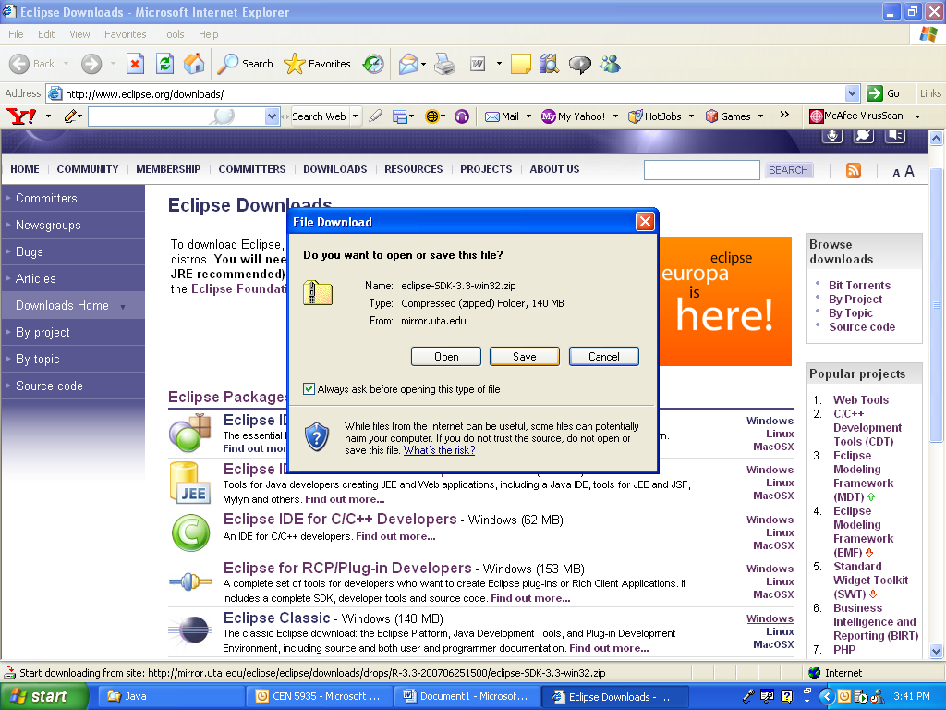

Choose save. You will be prompted for a save location. Save it in your folder called ‘Java’ under ‘My Documents’ to allow simple removal of this IDE zip files and executables in the future. Depending on your throughput, downloading may take a while since the zipped file is more than 100 MB.

1.b. Download JIGLOO Zip File

Now, download JIGLOO from http://www.cloudgarden.com/jigloo/
and scroll down until you reach “Installation using the zip file” as shown below:

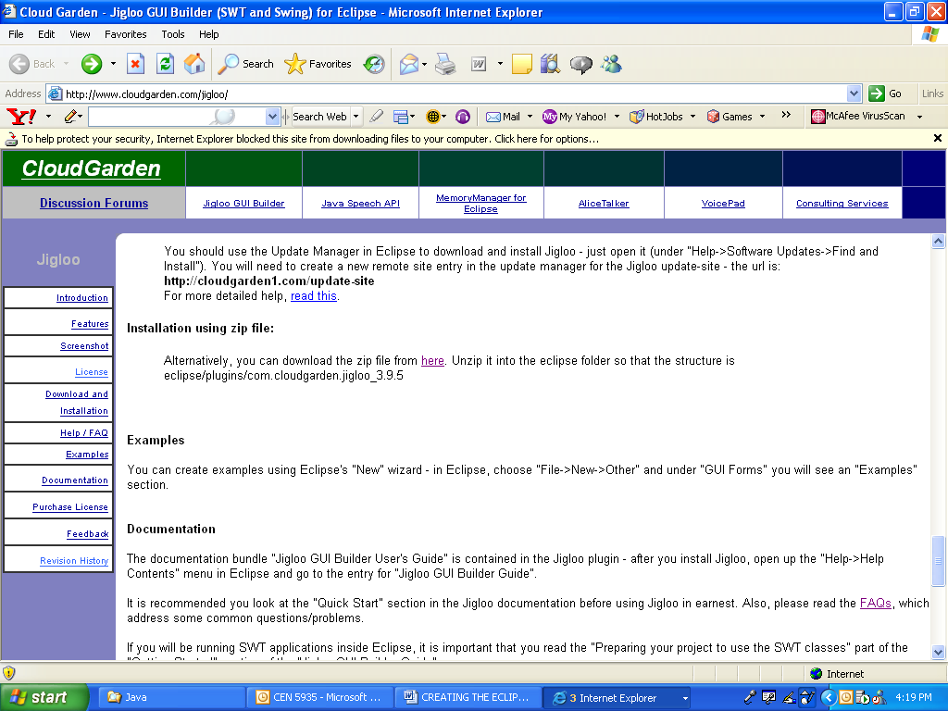

Click on the ‘here’ link. The following screen will appear:
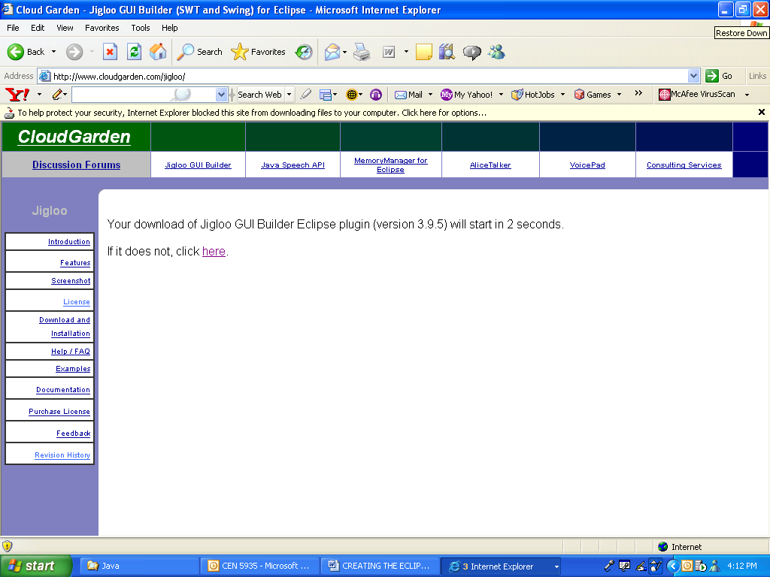

It may be necessary to click on the ‘here’ link. Save the file in the same ‘Java’ folder as the ECLIPSE zip file.

1.c. Download DIRBY Zip File

Last, go to the Derby website http://db.apache.org/derby/releases/release-10.2.2.0.cgi. Scroll down to the ‘Distributions’ area. There is a paragraph on two separate Eclipse plugins for Derby as shown near the bottom of the screen print below:

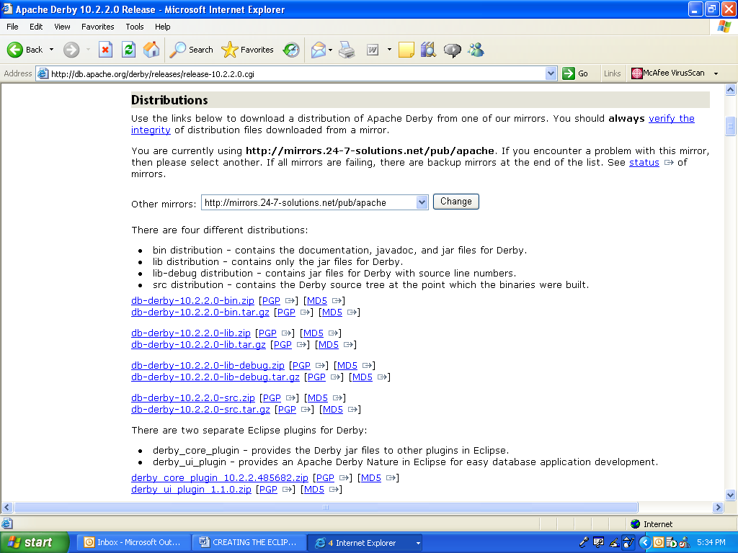

Download both Eclipse plugins labeled derby_core_plugin_10.2.2.485682.zip and
derby_ui_plugin_1.1.0.zip . Because of the frequency of releases, do not be alarmed if the release number is greater than these and still download. Save in the same ‘Java’ folder as the Eclipse and JIGLOO zip files.

1. CREATING the ENVIRONMENT

Look in the ‘Java’ folder in which the zip files were saved. There should be the following:
Java Compilers
Four additional zip folders:
one for Eclipse,
one for JIGLOO and
two for Derby.

Make sure all these zip folders are present before you continue.

1.a Unzipping your Eclipse File

- Unzip the Eclipse file by right clicking on the Eclipse folder
- Choose extract all.
- When the extraction wizard appears. Click Next .
- You will be prompted to specify the location to unzip the data.
- Choose the default which will unzip the data into ‘Java/Eclipse-SDK-3.3-Win32/Eclipse’ folder. (Note that the Eclipse-SKD-3.3-Win32 portion of the file directory structure may change based on the current version of Eclipse downloaded from the website and the operating chosen to download.)
- Click ‘Finish’.

1,b, Unzipping JIGLOO

- Proceed on by right clicking on the JIGLOO zip file and choosing ‘Extract All’.
- Click ‘Next’ in the extraction wizard.
- You will be prompted to specify the location to unzip the data
  - DO NOT CHOOSE THE DEFAULT THIS TIME
- Click Browse and go to the ‘Java/ Eclipse-SDK-3.3-Win32/Eclipse’ folder.
- Once this exact folder is selected, Click ‘OK”.
- Click “Next” Unzip will proceed.
- After the Unzip has completed, verify that the folder ‘com.cloudgarden.jigloo_4.0’ exists in the ‘Java/Eclipse-SDK-3.3-Win32/Eclipse/Plugins’ subdirectory.
- Click “Finish”

1.c. Unzipping DEBRY

For each of the Derby zip files, (remember there are two) unzip as follows:
- (Right click on the zip file, choose ‘Extract All’, Click ‘Next’.
- You will be prompted to specify the location to unzip the data’
  - DO NOT CHOOSE THE DEFAULT
- Click Browse and go to the ‘Java/Eclipse-SDK-3.3-Win32/Eclipse’ folder.
- Once the exact folder is selected, Click ‘OK’.
- Click ‘Next’. Unzip of Derby will proceed.
- Click “Finish”
After unzipping both DERBY files, verify that the folders under
‘Java/Eclipse-SDK-3.3-Win32/Eclipse/Plugins/’ exist:
org.apache.derby_core_plugin_10.2.2
org.apache.derby_ui_plugin_1.1.0
org.apache.derby.plugin.doc_1.1.0

