CIS 5930-09 Special topics
Advanced Algorithms

Spring 2005

Assignment 1

Due: 4 Feb 2005

- (20 points) Find the max flow for the following flow network, using the Edmonds-Karp algorithm. Show each step of the algorithm. In the breadth first search that you perform, choose the lexicographically smaller neighbor first. What is the minimum cut corresponding to the flow you determined?

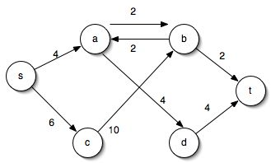

- (10 points) CLR exercise 26.1-7.

- (10 points) CLR exercise 26.2-4.

